| Change Request Form | |
| --- | --- |
|  | V2020.10 CR1001 Mobile Money API Definition |
| Document Summary | |
| Official Document Number, Document Title and Version Number | V2020.10 Mobile Money API Definition v1.0 (Current) |
| Official Document Type | Non-binding Permanent Reference Document |
| Change Request Security Classification | Non-confidential |
| Is this a new document or a Major or Minor Change? | Minor Update |
| Will this Change Request result in a Major or Minor version update? | Minor Version |
| This document is for | Discussion |
| Input Editor and Organisation |  |
| Additional Contributors | [List of contributors] |
| Issuing Group/Project | [Issuing Group/Project] |
| Approving Group/Project | [Approving Group/Project] |
| Change Request Creation Date | 01/05/2018 |
| What are the reasons for and benefits of creating this new document or Change Request? | Accessible APIs are a core requirement to ecosystem growth. However, currently, the API landscape is scattered, inconsistent and fragmented making it hard for operators and 3rd parties to interconnect efficiently – an issue a harmonised API can solve. |

© GSMA © 2018. The GSM Association (“Association”) makes no representation, warranty or undertaking (express or implied) with respect to and does not accept any responsibility for, and disclaims liability for the accuracy or completeness or timeliness of the information contained in this document. The information contained in this document may be subject to change without prior notice. This document has been classified according to the GSMA [Document Confidentiality Policy](https://infocentre-qa.concentra.co.uk/_layouts/Infocentre/InfocentreRedirect.aspx?WebId=4d56f3a7-dbc9-4a09-9a58-4aed6a0921d4&ListId=97eb8308-dd5f-422e-bbc5-8bee9731f160&ItemId=a8a9e2e4-c802-4e9c-b1f2-e85bafed771d). GSMA meetings are conducted in full compliance with the GSMA Antitrust Policy.

|  |  |  |  |
| --- | --- | --- | --- |
| Review Log (to be completed by GSMA Support Staff) | | | |
| Workflow Step | Document Review Comments | GSMA Support Staff Name | Comments Date |
| Step 1: Change Request Creation (no comments required) | | | |
| Step 2: Document Quality and/or Legal Review | | | |
| Document Quality Team | INSERT COMMENTS HERE  Please enter details for the Quality Review  Confirm Document Quality Team feedback  Record any issues, actions and key decisions | GSMA Support Staff Name | DD/MM/YY |
| Legal Review | INSERT COMMENTS HERE  Please enter details for the Legal Review  Confirm Legal feedback  Record any issues, actions and key decisions | GSMA Support Staff Name | DD/MM/YY |
| Step 3: Formal Review | | | |
| Group(s)/Project(s) Review(s) Comments and Feedback | INSERT COMMENTS HERE  Please enter details for the Group(s)/Project(s) Review(s)  Record any issues, actions and key decisions  Confirm outcome of Formal Review | GSMA Support Staff Name | DD/MM/YY |
| Step 4: Formal Approval(s) | | | |
| Group(s)/Project(s) Approval(s) Comments and Feedback | INSERT COMMENTS HERE  Please enter details for the Group(s)/Project(s) Approval(s)  Record any issues, actions and key decisions  Confirm outcome of Formal Approval | GSMA Support Staff Name | DD/MM/YY |

**Document History**

|  |  |  |  |  |
| --- | --- | --- | --- | --- |
| Version | Date | Brief Description of Change | Approval Authority | Editor / Company |
| 1.1 | 4th May 2018 | * Aligned property names in this document to the actual properties as held in the Swagger definition to remove confusion * Changed correlation ID mandatory to optional. * Added X-User-Credential-1 and X-User-Credential-2. Only for use when Open ID is not possible for end-user authentication. * Added X-Channel which can be used to identify the API invocation channel. * Generally aligned headers with the security specification. * Clarified difference between request and response custom headers * Changed all instances of ‘*Date Created*’ to ‘*Creation Date*’ and ‘*Date Modified*’ to ‘*Modification Date*’ in the document to align with the Swagger definition. * Added Bill Status property to Bills API * Added Payment Type property to Bill Payments API * Added Bill Companies APIs * Added new Account Identifiers - consumerno, serviceprovider, storeid, bankname, bankaccounttitle * Added AuthorisationCodes APIs * Add Transaction Fees to Transactions, Reversals and Quotations APIs * Added new transaction filters – Type and Status * Modified the MSISDN regular expression (refer to Swagger) * Added clarity on valid formats relating to regular expressions * Added new API to enable the Transaction Type to be passed in the URL for a POST. | WG #nn | GSMA |

**Other Information**

|  |  |
| --- | --- |
| Type | Description |
| Document Owner | <Working Group/Project> |
| Editor / Company |  |

Table of Contents

1 Introduction 7

1.1 Definitions of Terms 7

2 API Quick Start Guide 10

3 API Fundamentals 11

3.1 URI 11

3.2 Operations 11

3.3 Patch Specifics 11

3.4 Resource Naming 11

3.5 Identifying the Resource 12

3.6 Client Correlation ID 13

3.7 Use Case Flow Patterns 13

3.8 Case Sensitivity 13

3.9 HTTP Header Information 13

3.9.1 HTTP Standard Request Headers 13

3.9.2 HTTP Standard Response Headers 14

3.9.3 Custom Request Headers 14

3.9.4 Custom Response Headers 15

3.10 API Versioning 15

4 API Service Definition 17

4.1 Transactions API 19

4.2 Reversals API 22

4.3 Batch Transactions API 25

4.3.1 Batch Transactions API 25

4.3.2 Batch Rejections API 27

4.3.3 Batch Completions API 28

4.4 Accounts APIs 30

4.4.1 Identifying a Target Account 30

4.4.2 Supported Account Operations 30

4.4.3 Returning Transactions for an Account 30

4.4.4 Accounts Status API 31

4.4.5 Account Balances API 32

4.4.6 Account Name API 33

4.5 Statement Entries API 33

4.6 Bills API 35

4.7 Bills Payments API 36

4.8 Bill Companies API 36

4.9 Debit Mandates API 38

4.9.1 Debit Mandates Object 38

4.10 Links API 39

4.10.1 Link Object 39

4.11 Quotations API 40

4.12 Authorisation Codes API 43

4.12.1 Authorisation Codes Object 43

5 Supporting Objects 45

5.1 International Transfer Information Object 45

5.2 KYC Information Object 46

5.3 Name Object 47

5.4 ID Document Object 47

5.5 Address Object 48

5.6 Account Identifiers Object 48

5.7 Quotes Object 49

5.8 Metadata Object 50

5.9 Supplementary Bill References Object 50

5.10 Transaction Types Object 50

5.11 Channel Types Object 51

5.12 Fees Object 51

6 Enumerations 52

6.1 ISO Currency Codes 52

6.2 Transaction Types 52

6.3 ID Types 52

6.4 Account Identifiers 53

6.5 ISO Country Codes 54

6.6 Delivery Method Type 55

6.7 Frequency Type 55

7 API Behaviour & Error Handling 57

7.1 Request States 57

7.2 API Behavioural Model 58

7.2.1 Overview 58

7.2.2 Request State Object 58

7.2.3 Sequence Flows 59

7.2.4 API Flow Patterns 59

7.3 HTTP Status Responses and Error Categories 66

7.3.1 Client Error Categories 66

7.3.2 Server Error Categories 66

7.4 Error Codes Definition 67

7.5 Errors Object Definition 68

7.6 API Heartbeat 68

7.7 Missing Response Retrieval 69

7.8 Harmonised Error Codes 70

# Introduction

The purpose of this document is to detail the design principles, objects, behaviours and error handling for the Mobile Money API.

The overriding goal of the API is to enable all parties to implement mobile money API’s in a flexible, yet consistent manner. This has been achieved by implementing the following principles:

* Use of REST architectural principles.
* Providing a set of well-defined objects that are abstracted from the underlying object representations held in the various mobile money systems. This allows an API client to construct an API message without requiring specific knowledge of the target server implementation.
* Creation of a standard set of transaction types and other key enumerations, removing the need for developers to map for each and every API implementation.
* Use of ISO international standards for enumerators such as currency and country codes
* Use of supplementary metadata and sub-types to enable use case and/or mobile money provider-specific properties to be conveyed where necessary.
* Recognising that no common mobile money account identifier exists, use of a flexible construct to enable the target account(s) and transaction parties to be identified using one or multiple identifier types.

This documentation contains the following sections:

* **Quick Start Guide****.** Provides a basic reference point to enable a developer to identify which objects and URI’s to use for their target use cases.
* **API Fundamentals**. The core principles and constructs that underpin the API.
* **API Service Definition**. Details the available Request State Object API Services.
* **API Supporting Object Definition**. Details the properties for the supporting objects that constitute the harmonised API.
* **Enumerations**. Describes all of the list of values that are applied to specific object properties. Where international standards are used, appropriate references are supplied.
* **API State and Error Handling**. Describes behavioural aspects of the API and details error handling including error code definition, Heartbeat object definition and polling/callback standards on retries and timeouts.

## Definitions of Terms

|  |  |
| --- | --- |
| **Term** | **Description** |
| ATM | Automated Teller Machine. Enables customer to be able to perform financial transactions without the need for a human cashier. For mobile money, the ATM machine can be considered as an automated agent, allowing withdrawals and some case deposits from and to the customer’s wallet. |
| Agent | A person or business that is contracted to facilitate transactions for users. The most important of these are cash-in and cash-out (i.e. loading value into the mobile money system, and then converting it back to cash again); in many instances, agents register new customers too. |
| API Service | An API Service comprises of a URI which when combined with a HTTP Operation (GET, PATCH, POST) enables a specified operation to be conducted on a specific resource or set of resources. |
| Application Programming Interfaces (APIs) | In computer programming, an application programming interface (API) is a set of routines, protocols, and tools for building software applications. An API expresses a software component in terms of its operations, inputs, outputs, and underlying types. |
| Authentication | Confirms the identity of the entity that is requesting the service by verifying supplied credential(s). In this document, the requesting entity is typically referred to as the initiator or sender. |
| Authorisation | Authorisation provides an authenticated identity with access to the system resources/services to which they are entitled. In the context of this document, the requesting entity (initiator) is provided with a defined set of services and functions that they can perform over API. |
| Business | Describes an entity such as a public limited or limited company that uses mobile money as a service. This includes taking bill payments, making bill payments and disbursing salaries |
| Client | Describes the calling system/party that initiates and interacts with the API service. The Client may or may not be the debit or credit party |
| GUID | Globally Unique Identifier. GUIDs are usually stored as 128-bit values and are used for as the datatype for correlation IDs in the mobile money API. |
| HTTP | Acronym for Hyper Text Transfer Protocol. HTTP is the foundation of data communication for the World Wide Web. HTTP is the protocol to exchange or transfer hypertext. |
| ISO | International Organisation for Standardisation. A number of ISO standards are used with the mobile money API. |
| ITU | International Telecommunications Agency. ITU MSISDN format standards have been adopted for the mobile money API. |
| JSON | Acronym for JavaScript Object Notation. Used to transmit data objects containing attribute/value pairs. One of two protocols (the other being XML) considered as the basis for a Data Exchange format for mobile money API harmonisation |
| Merchant | A retail merchant that accepts e-Money from mobile money customers in exchange for goods and/or services. |
| MSISDN | A number uniquely identifying a subscription in a GSM or a UMTS mobile network. Analogous with a mobile phone number. |
| Object | An object holds a set of properties. Objects can be combined or used in isolation to provide a representation of a resource. |
| Organisation | Describes a non-business entity such as a charity or government department that uses mobile money as a service. This includes taking bill payments, making bill payments and disbursing salaries |
| Provider | Hosts the Mobile Money API services (or subset of). |
| Resource | A resource is the target for an API operation as identified in the API request. Resources are conceptually different from the representations that are returned to the client. |
| REST-based API | In computing, Representational State Transfer (REST) is the software architectural style adopted by many organisations that offer APIs. REST stipulates that interacting systems exhibit the following characteristics:   * **Client-Server**. Responsibilities between clients and servers are explicitly defined. * **Stateless**. No context is stored between client and server during communication. * **Cacheable**. As on the World Wide Web, clients and intermediaries can cache responses * **Layered System**. A client cannot ordinarily tell whether it is connected directly to the end server, or to an intermediary along the way.   **Uniform Interface**. A uniform interface simplifies and decouples the architecture, which enables each part to evolve independently. |
| URI | Acronym for Uniform Resource Identifier. The URI is a string of characters used to identify a resource (such as an account, for example). In APIs a URI is represented in the form of a URL which is generally used to identify the service to invoke. |
| Wallet | Term used in this document to describe the store of value that identities (customers, agents, merchants and businesses) use to store e-Money. In general, the document uses the term Account in place of Wallet. |

# API Quick Start Guide

|  |  |  |
| --- | --- | --- |
| **I want to** | **URI Format** | **Refer to these sections** |
| Make a Bill Payment | /accounts/bills/payments | Bill Payments API |
| Create or view a Disbursement | /transactions | Transactions APIs |
| Create or view a Deposit | /transactions | Transactions APIs |
| Create or view an International transfer | /transactions | Transactions APIs |
| Create or view a Merchant Payment | /transactions | Transactions APIs |
| Create or view an Adjustment (including refunds) | /transactions | Reversals API |
| Create or view a Reversal | /transactions | Reversals API |
| Create or view a Domestic Transfer | /transactions | Transactions APIs |
| Create or view a Withdrawal | /transactions | Transactions APIs |
| View an Account Status | /accounts/status | Accounts APIs  Accounts Status API |
| View Balance(s) for an account | /accounts/balance | Accounts APIs  Balance API |
| View an Account Holders Name (Name Lookup) | /accounts/accountname | Accounts APIs  Account Name API |
| View Account Statement Entries for an account | /accounts/statemententries | Statement Entries API |
| View a specific statement Entry | /statemententries | Statement Entries API |
| View Bill Payment Service Providers | /accounts/billcompanies | Bill Companies API |
| View Bills for presentment | /accounts/bills | Bills API |
| Create or update Debit Mandates | /accounts/debitmandates | Debit Mandates API |
| Create, view or Delete Authorisation Codes | /accounts/authorisationcodes | Authorisation Codes API |
| Create or view an International Transfer Quotation | /quotations | Quotations API |
| Create, view or update an account to account Link | /accounts/links | Links API |
| Create a batch of transactions | /batchtransactions | Batch Transactions API |
| Retrieve batch transaction errors | /batchtransactions/rejections | Batch Transactions API |
| Retrieve batch transaction completions | /batchtransactions/completions | Batch Transactions API |

# API Fundamentals

## URI

All services exposed by the harmonised Mobile Money API use the following URI format:

**{…]/{version}/mm/{Resource}**

Where:

* **…** is defined upon implementation of the API by the API provider.
* **version** is as per standards defined in the API Versioning section.
* **mm** is literal for ‘Mobile Money’
* **resource** identifies the object and resource that is the subject of the API.

## Operations

The API supports three types of operations, each represented by HTTP Verb as shown below:

* **POST**. Used to create a resource for a given resource type. Transactions, Quotations and Debit Mandates can be created using the API.
* **PATCH**. Used to update a resource for a given resource type. Debit Mandates and Links can be updated using the API. But note that only specific properties can be updated – refer to the relevant API service for more information.
* **GET**. Used to return a representation(s) of a resource(s) or collection of resources. All resources support GET operations.

## Patch Specifics

Updates to resources are accomplished by use of the HTTP PATCH operation. The proposed PATCH format is based upon [IETF RFC 6902](https://tools.ietf.org/html/rfc6902). Two specific operations are supported:

**Replace**. This operation replaces the value of the target property with the supplied value. An example of a **replace** operation is **[*{ "op": "replace", "path": "/XYZ", "value": test }]*** where XYZ is the target property.

## Resource Naming

The format of the resource part of the URI identifies the type of resource and if applicable, the specific **resource** for which an operation is to be performed. Resources are generally reflected in plural and by use of nouns. Primary URI constructs for the API are as follows:

***/transactions***. Identifies a transaction resource.

* ***/accounts***. Identifies the financial resource that holds the funds. Examples include bank accounts and mobile wallets.
* ***/quotations***. The resource that holds the quote or quotes for international remittance quotations.
* ***/statemententries***. The resource that returns an account statement representation. This is typically qualified by /accounts but can be used in isolation to return a specific statement entry if the transaction reference is known.
* ***/accounts/debitmandates***. The resource that holds the debit mandate instructions, i.e. mandates that allow a Payee to deduct funds from a Payers account.
* ***/accounts/links***. Represents an account to account link between two systems.
* ***/accounts/authorisationcodes***. Represents an authorisation code which pre-authorises a transaction.
* ***/accounts/bills***. Represents a bill that is due to be paid or has been paid.
* ***/accounts/accountname***. Represents the primary account holders name.
* ***/accounts/balance***. Represents the balance(s) associated with an account.
* ***/accounts/status***. Represents the ability of the account to receive/send funds.
* ***/batchtransactions***. Represents a collection of transactions and related batch metadata.

A more exhaustive list of permitted resources and permitted resource hierarchies can be found in the detailed sections of this document.

## Identifying the Resource

The harmonised Mobile Money API has adopted a RESTful approach to identifying the resource on which an operation is to be performed. Where possible, the identifier is specified following the resource name in the URI. In some cases, more than one identifier is required to identify the resource or there is a choice on which identifier to use. Therefore, flexibility has been built into the URI to cater for these cases. This is illustrated in the following table.

|  |  |  |  |
| --- | --- | --- | --- |
| **Resource** | **Operation** | **Identifier** | **Identifier Placement** |
| Transactions | GET | Transaction Reference | URI |
| Accounts | GET | Various Account Identifiers (see Accounts for details) | URI |
| Mandates | PATCH and GET | Mandate Reference | URI |
| Quotations | PATCH and GET | Quotation Reference | URI |
| StatementEntries | GET | None if qualified by Accounts. If individual entry, then use Transaction Reference | URI |
| Links | PATCH and GET | Link Reference | URI |
| Bills | GET | Account Identifiers | URI |
| Bill Payments | POST | Bill Payment Reference and Account Identifiers | URI |
| BatchTransactions | PATCH and GET | Batch Reference | URI |

## Client Correlation ID

A Client Correlation ID is to be supplied by the API client on HTTP POST and PATCH requests. Put simply, the Client Correlation ID is a unique identifier that enables the client to correlate the API request with the resource created/updated by the provider. The client correlation ID is captured in the [HTTP Header](#_HTTP_Header_Information).

The format for the correlation ID is a GUID. Critically, the correlation ID supports safe operations. A POST request that is submitted with a correlation that has already been supplied will be rejected as unsafe, thus avoiding transaction duplication.

## Use Case Flow Patterns

All Use Cases supported by the API are built on standard flow patterns. Flow patterns exist for viewing, creating and updating records (resources). Flow patterns can be combined in a single use case. For example, a domestic transfer may involve a name check on the recipient platform prior to a request to create a transaction. There are some simple rules to follow when using flow patterns. These are illustrated below:

* **Viewing**. Only synchronous flows are supported for viewing resource(s). For example, a HTTP GET request to view balances must result in a HTTP response yielding the representation of the resource or representation of the error.
* **Creating/Updating.** Synchronous and asynchronous flows are supported. A synchronous flow involves a definitive result (resource representation or error representation returned) being provided in the HTTP POST response. An asynchronous flow is supported by two mechanisms – Callback and Polling. These are described in more detail in the Request State Object section.

## Case Sensitivity

All enumeration values referenced within the API use lower case notation – this includes acronyms and abbreviations. The only exceptions are for

* ISO Codes (country and currency) – the API uses these codes as defined per ISO.
* Errorcodes. Upper Case is used to identify the first letter of each word to assist readability.

In this document properties are split into words with the first character capitalised for readability. However, the API properties in the actual API (Swagger definition) use camelCase format.

## HTTP Header Information

The following header information can be supplied for the mobile money API.

### HTTP Standard Request Headers

|  |  |  |  |
| --- | --- | --- | --- |
| **Header** | **Value** | **Optionality** | **Notes** |
| Accept | application/json | Mandatory |  |
| Accept-Charset | Utf8 | Mandatory |  |
| Authorization | Authorization: Basic {base64Encode(concatenated client's username and password)} OR OAuth2 Access Token. | Mandatory |  |
| Content-Length | {length of request content in 8-bit bytes} | Mandatory |  |
| Content-Type | application/json | Mandatory |  |

### HTTP Standard Response Headers

|  |  |  |  |
| --- | --- | --- | --- |
| **Header** | **Value** | **Optionality** | **Notes** |
| Content-Length | {length of response content in 8-bit bytes} | Conditional | Applicable only if the HTTP response contains JSON body |
| Content-Type | application/json; charset=utf-8 | Conditional | Applicable only if the HTTP response contains JSON body |

### Custom Request Headers

|  |  |  |  |
| --- | --- | --- | --- |
| **Header** | **Value** | **Optionality** | **Notes** |
| X-API-Key* | Used to pass pre-shared client's API key to the server | Conditional |  |
| X-Date | {The date and time that the message was sent in HTTP-date format - RFC 7231} | Mandatory | Used for Basic message integrity checks |
| X-Client-Id* | Used to pass pre-shared client's identifier to the server | Conditional | Can be used in addition to X-API-Key. |
| X-Content-Hash* | SHA-256 hex digest of the request content (encrypted or plain) | Conditional | Applicable only if the HTTP request contains JSON body and basic data integrity checking is to be performed. |
| X-CorrelationID | GUID | Conditional | Use for asynchronous operations. Also refer to Client Correlation ID. |
| X-User-Credential-1 | Contains an authentication credential of the end user (e.g. PIN, Password). | Conditional | Should only be used when OAuth 2.0/OIDC authorisation framework has not been implemented by the API Provider. |
| X-User-Credential-2 | Contains an authentication credential of the end user (e.g. PIN, Password). | Conditional | Should only be used when OAuth 2.0/OIDC authorisation framework has not been implemented by the API Provider. |
| X-Channel | String containing the API invocation channel. | Conditional | Used to identify the API invocation channel. |

### Custom Response Headers

|  |  |  |  |
| --- | --- | --- | --- |
| **Header** | **Value** | **Optionality** | **Notes** |
| X-Records-Available-Count | Integer containing number of records that are available to be returned | Conditional | Used in the event of pagination |
| X-Records-Returned-Count | Integer containing the number of records that have been returned | Conditional | Used in the event of pagination |

*Please refer to the Mobile Money API Security Design for further information.

## API Versioning

When changes are made to the Mobile Money API, a new version is released. There are two types of API versions – minor (backwards compatible) and major (backwards-incompatible) versions.

The following types of changes are considered to be backwards compatible and hence minor:

* Addition of new API Services.
* Adding optional request properties and/or optional input parameters such as query strings to existing objects.
* Addition of new properties to existing API responses.
* Changing the order of properties within a request or response object.
* New error codes.

The following types of changes are considered to be backwards incompatible and hence major:

* Introducing mandatory properties.
* Changing datatypes on properties.
* Changes to API URIs.

The version that a client intends to use is indicated URI. Format is ‘X.Y’ where ‘X’ is the major version and ‘Y’ is the minor version. Both versions are sequentially numbered. Note that when a major version is incremented, the minor version is reset to zero. The initial released version of the API is 1.0.

There are many different mobile money and third party providers and hence clients connecting to multiple providers are likely to interact with different versions of the API. Client code developed against an older minor version on one client will work on all newer minor versions existing on other clients. However, client code developed against a new minor version will not necessarily work against older minor versions.

# API Service Definition

All API Services that form the harmonised mobile money API and related objects are detailed within the API Definition and Supporting Object sections. The relationships between objects is illustrated in the figure below.

Note: That green represents objects that are accessible via an API service and blue represents objects that are referenced.

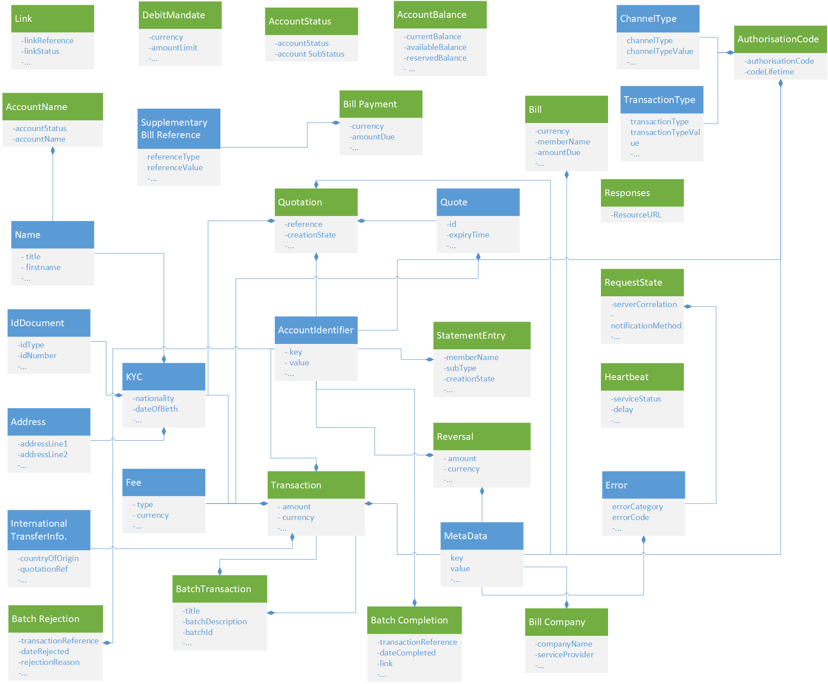

1. . API Object Relationships

Object properties are detailed within tables that contain the following information:

* The property name.
* The property type.
* Description of the property.
* Optionality of the property, i.e. whether the property must be supplied. Optionality is identified as per follows:

→ Request optionality

← Response optionality

O Property is optional

M Property is mandatory

NA Property does not need to be supplied. If supplied, it will be ignored.

* Reference where the property is a collection/array and is defined by another object.
* Validation applied to the property, including enumeration, property length and use of regular expressions to validate format.

Note: All String properties have a default maximum length of 256 characters unless specified otherwise.

## Transactions API

The Transactions API is used for all operations involving mobile money financial transactions. This currently covers:

* Creating a Transaction (**POST**)
* Returning a representation of one or more transactions (**GET**)

Transactions are used for a wide range of use cases including Merchant Payments, International Transfers, Domestic Transfers and agent cash-in/cash-out. Reversals and Adjustments are also treated as Transactions.

and the URI can be one of two formats:

* **/transactions**. Can be used for GET and POST.
* **/transactions/type/{transactiontype}**. POST only. An alternative to the above URI. It can be used when the providers API Gateway requires that the transaction type is identified in the URL. When this URI is used, the Transaction Type does not need to be supplied in the request body.

The specific resource can be identified by Transaction Reference as per below:

|  |  |  |
| --- | --- | --- |
| **Operation** | **Identifier** | **Identifier Placement** |
| GET | Transaction Reference | The format is **/transactions*/{Transaction Reference}*** |

The object definition for Transactions as provided below:

|  |  |  |  |  |  |
| --- | --- | --- | --- | --- | --- |
| Transaction Base Object Properties | | | | | |
| Name | **Type** | **Description** |  | **Reference** | **Validation** |
| amount | String | Principle Transaction Amount | →M  ←M |  | If supplied, amount must contain two decimal places separated by ‘.’ |
| currency | String | Currency of the principal transaction amount. | →M  ←M |  | Enumeration = ISO Currency Codes |
| type | String | The harmonised Transaction Type (not required if passed in the URL) | →M  ←M |  | Enumeration = Transaction Types |
| subType | String | A non-harmonised sub-classification of the type of transaction. Values are not fixed and usage will vary according to Provider. | →O  ←O |  |  |
| transactionStatus | String | Indicates the status of the transaction as stored by the API provider. | →NA  ←M |  |  |
| descriptionText | String | Free format text description of the transaction provided by the client. This can be provided as a reference for the receiver on the SMS and on the account statement. | →O  ←O |  |  |
| requestDate | DateTime | The creation date and time of the transaction as supplied by the client. | →M  ←M |  |  |
| creationDate | DateTime | Date and time when the transaction was created by the API Provider | →NA  ←O |  |  |
| modificationDate | DateTime | Date and time when the transaction was modified by the API Provider | →NA  ←O |  |  |
| transactionReference | String | Unique reference for the transaction. This is returned in the response by API provider. | →NA  ←M |  |  |
| transactionReceipt | String | Transaction receipt number as notified to the parties. This may differ from the Transaction Reference. | →NA  ←O |  |  |
| requestingOrganisationTransactionReference | String | A reference provided by the requesting organisation that is to be associated with the transaction. | →O  ←O |  |  |
| oneTimeCode | String | A one-time code that can be supplied in the request or can be generated in the response depending upon the use case. | →O  ←O |  |  |
| geoCode | String | Indicates the geographic location from where the transaction was initiated. | →O  ←O |  |  |
| debitParty | Reference Array | A collection of key/value pairs that enable the debit party to be identified. Keys include MSISDN and Wallet Identifier. | →M  ←M | Account Identifiers |  |
| creditParty | Reference Array | A series of key/value pairs that enable the credit party to be identified. Keys include MSISDN and Wallet Identifier. | →M  ←M | Account Identifiers |  |
| senderKYC | Reference | A collection of properties detailing the KYC of the transaction Sender, typically used for International Transfers. | →O  ←O | KYC Information |  |
| recipientKYC | Reference | A collection of properties detailed the KYC of the transaction Recipient, typically used for International Transfers. | →O  ←O | KYC Information |  |
| internationalTransferInformation | Reference | A collection of properties detailed information specifically used for international transfers. | →O  ←O | International Transfer Information |  |
| originalTransactionReference | String | For reversals and refunds, this property indicates the transaction which is the subject of the reversal | →O  ←O |  |  |
| servicingIdentity | String | The property is used to identify the servicing identity for ‘present’ transactions, e.g. till, POS ID, assistant ID | →O  ←O |  |  |
| requestingLei | String | Legal Entity Identifier of the organisation that is requesting the transaction. | →O  ←O |  | Refer to LEI format as defined here:  <https://www.leiroc.org/lei.htm> |
| receivingLei | String | Legal Entity Identifier of the organisation that is receiving the transaction. | →O  ←O |  | Refer to LEI format as defined here:  <https://www.leiroc.org/lei.htm> |
| fees | Reference Array | Allows the passing and/or returning of all fees pertaining to the transaction. | →O  ←O | Fees Object |  |
| metadata | Reference Array | A collection of key/value pairs. These can be used to populate additional transaction properties. | →O  ←O | Metadata |  |

## Reversals API

The Reversals API is used to reverse a financial transaction. The originating transaction reference must be provided in the URI in order to identify the transaction to be reversed. For a partial reversal, the amount needs to be supplied. It should be noted however that API Providers may not support partial reversals and will return an error if a partial amount is supplied. This API can also be used for adjustments.

Note: That only reversal creation is supported. For viewing reversals, the Transactions API should be used. Format is **/transactions*/{Original Transaction Reference}/reversals***.

The object definition for Reversals is provided below:

|  |  |  |  |  |  |
| --- | --- | --- | --- | --- | --- |
| Reversal Base Object Properties | | | | | |
| Name | **Type** | **Description** |  | **Reference** | **Validation** |
| amount | String | Principle Transaction Amount | →O  ←O |  | If supplied, amount must contain two decimal places separated by ‘.’ |
| currency | String | Currency of the principal transaction amount. | →O  ←O |  | Enumeration = ISO Currency Codes. |
| type | String | The harmonised Transaction Type | →M  ←M |  | Enumeration = Transaction Types  Note that only Reversals and Adjustments are supported. |
| subType | String | A non-harmonised sub-classification of the type of transaction. Values are not fixed and usage will vary according to Provider. | →O  ←O |  |  |
| transactionStatus | String | Indicates the status of the transaction as stored by the API provider. | →NA  ←M |  |  |
| descriptionText | String | Free format text description of the transaction provided by the client. This can be provided as a reference for the receiver on the SMS and on the account statement. | →O  ←O |  |  |
| requestDate | DateTime | The creation date and time of the transaction as supplied by the client. | →M  ←M |  |  |
| creationDate | DateTime | Date and time when the transaction was created by the API Provider | →NA  ←O |  |  |
| modificationDate | DateTime | Date and time when the transaction was modified by the API Provider | →NA  ←O |  |  |
| transactionReference | String | Unique reference for the transaction. This is returned in the response by API provider. | →NA  ←M |  |  |
| transactionReceipt | String | Transaction receipt number as notified to the parties. This may differ from the Transaction Reference. | →NA  ←O |  |  |
| geoCode | String | Indicates the geographic location from where the transaction was initiated. | →O  ←O |  |  |
| requesting OrganisationTransactionReference | String | A reference provided by the requesting organisation that is to be associated with the transaction. | →O  ←O |  |  |
| debitParty Identifier | Reference Array | A collection of key/value pairs that enable the debit party to be identified. Keys include MSISDN and Wallet Identifier. | →O  ←O | Account Identifiers |  |
| creditParty Identifier | Reference Array | A series of key/value pairs that enable the credit party to be identified. Keys include MSISDN and Wallet Identifier. | →O  ←O | Account Identifiers |  |
| originalTransactionReference | String | For reversals and refunds, this property indicates the transaction which is the subject of the reversal | →NA  ←M |  |  |
| requesting LEI | String | Legal Entity Identifier of the organisation that is requesting the transaction. | →O  ←O |  | Refer to LEI format as defined here:  <https://www.leiroc.org/lei.htm> |
| receiving LEI | String | Legal Entity Identifier of the organisation that is receiving the transaction. | →O  ←O |  | Refer to LEI format as defined here:  <https://www.leiroc.org/lei.htm> |
| servicingIdentity | String | The property is used to identify the servicing identity for ‘present’ transactions, e.g. till, POS ID, assistant ID | →O  ←O |  |  |
| fees | Reference Array | Allows the passing and/or returning of all fees pertaining to the transaction. | →O  ←O | Fees Object |  |
| metadata | Reference Array | A collection of key/value pairs. These can be used to populate additional transaction properties. | →O  ←O | Metadata |  |

## Batch Transactions API

As the name implies, this API allows clients to submit batches of transactions in a single HTTP request. Batch processing is always asynchronous. Batch processing follows a simple state transition:

1. Client submits the batch for processing via a ‘***POST /batchtransactions***’.
2. The client will return the RequestState object indicating whether a callback will be provided or polling is required.
3. The API provider will parse the batch in order to determine whether the transactions are capable of being processed.
4. Once parsing has completed, the API provider will set the batch status in the batchtransactions object to ‘**created**’.
5. The client will be able to retrieve the batchtransactions object by invoking GET /batchtransactions using the object reference provided by the RequestState object.
6. If errors are indicated, i.e. some of the transactions failed parsing, the client is able to retrieve the errors via ‘**GET /batchtransactions/rejections**’.
7. Depending upon the business process, the client (or another client) can approve the batch for posting by issuing a ‘***PATCH /batchtransactions***’ in order to update the status to ‘**approved**’.
8. As per step 2, a RequestState object will be returned indicating whether a callback will be provided or polling is required.
9. The API provider will then post the transactions in the batch taking into account any scheduling considerations.
10. Once posting is completed, the API provider will set the batch status in the batchtransactions object to ‘**completed**’.
11. The client will be able to retrieve the batchtransactions object by invoking GET /batchtransactions using the object reference provided by the RequestState object.
12. the client will also be able to retrieve a list of successful transaction completions ***‘/batchtransactions/completions***’ and transaction failures ‘***/batchtransactions/rejections***’.

### Batch Transactions API

As described above, this API enables clients to submit and approve a batch of transactions. The API allows transactions of multiple types to be include in a single batch. The following operations are supported:

* Submit a batch: ‘POST /batchtransactions’
* Approve a batch: ‘PATCH /bathtransactions/{Batch ID}’. The Batch Status needs to be set to ‘approved’.
* View details regarding batch processing: ‘GET /batchtransactions/{batch ID}’

|  |  |  |  |  |  |
| --- | --- | --- | --- | --- | --- |
| Batch Transaction Object Properties | | | | | |
| Name | **Type** | **Description** |  | **Reference** | **Validation** |
| batchTitle | String | Client-provided title for the batch | →O  ←O |  |  |
| batchDescription | String | Client-provided description of the batch. | →O  ←O |  |  |
| batchID | String | Identifier for the Batch that is assigned by the API provider. This ID is used by the client on subsequent GET or PATCH operations. | →N/A  ←M |  |  |
| batchStatus | String | Indicates the status of the batch. | →O  ←M |  | Enumeration = created, approved, completed |
| processingFlag | Boolean | Indicates whether the batch is currently undergoing processing by the API Provider. | →O  ←O |  |  |
| scheduledStart Date | Datetime | If the batch has been scheduled, the expected start time is provided here. | →O  ←O |  |  |
| creationDate | Datetime | Indicates when the batch was created as recorded by the API provider. | →NA  ←M |  |  |
| approvalDate | Datetime | Indicates when the batch was approved as recorded by the API provider. | →NA  ←M |  |  |
| completionDate | Datetime | Indicates when the batch was completed as recorded by the API provider. | →NA  ←M |  |  |
| rejectionCount | Integer | Indicates the number of records that have been rejected, either during parsing or during final processing. | →NA  ←O |  |  |
| parsingSuccessCount | Integer | Indicates the number of records that have been parsed successfully. | →NA  ←O |  |  |
| completedCount | Integer | Indicates the number of records that have been successful completed. | →NA  ←O |  |  |
| transactions | Reference Array | Collection of Transactions that are to be processed. Note that the representation of each completed transaction can be retrieved via the ‘/completions API. | →M  ←N/A | Transactions |  |

### Batch Rejections API

As described above, this API enables clients to retrieve information on all transactions that have either failed parsing or have failed to be completed. Only GET is supported. Format is ‘***batchtransactions/{Batch ID}/rejections***’

In order to filter the number of records returned, the following query strings can be used:

|  |  |  |  |
| --- | --- | --- | --- |
| **Parameter** | **Type** | **Format** | **Description** |
| Limit | Integer | N/a | Supports pagination. If this is not supplied, then the server will apply a limit of 50 records returned for each request. |
| Offset | Integer | N/A | Supports pagination. This value will indicate the cursor position from where to retrieve the set of records. For example, a limit of 50 and offset of 10 will return records 10 to 60. |
| fromDateTime | String | DateTime | Indicates the minimum date for which records should be returned. |
| toDateTime | String | DateTime | Indicates the maximum date for which records should be returned. |

Note: That HTTPresponse metadata is returned with each response that is paginated indicating the total number of records available and total number of records returned.

|  |  |  |  |  |  |
| --- | --- | --- | --- | --- | --- |
| Batch Rejection Object Properties | | | | | |
| Name | **Type** | **Description** |  | **Reference** | **Validation** |
| transactionReference | String | Transaction Reference as assigned by the API provider. | →N/A  ←O |  |  |
| rejectionDate | Datetime | Date and time of the rejection. | →N/A  ←M |  |  |
| debitParty | Reference Array | The debit party identifiers for the transaction as specific in the batch request. | →N/A  ←M | Account Identifiers |  |
| creditParty | Reference Array | The credit party identifiers for the transaction as specific in the batch request. | →N/A  ←M | Account Identifiers |  |
| rejectionReason | String | The reason for the transaction request as indicated by the API provider. | →N/A  ←M |  |  |
| requestingOrganisationTransactionReference | String | A reference provider by the requesting organisation that is to be associated with the transactions | →N/A  ←O |  |  |

### Batch Completions API

This API lists all transactions that have successfully completed for a given batch. Only GET is supported. Format is ‘***batchtransactions/{Batch ID}/completions***’.

In order to filter the number of records returned, the following query strings can be used:

|  |  |  |  |
| --- | --- | --- | --- |
| **Parameter** | **Type** | **Format** | **Description** |
| Limit | Integer | N/a | Supports pagination. If this is not supplied, then the server will apply a limit of 50 records returned for each request. |
| Offset | Integer | N/A | Supports pagination. This value will indicate the cursor position from where to retrieve the set of records. For example, a limit of 50 and offset of 10 will return records 10 to 60. |
| fromDateTime | String | DateTime | Indicates the minimum date for which records should be returned. |
| toDateTime | String | DateTime | Indicates the maximum date for which records should be returned. |

Note: That HTTPresponse metadata is returned with each response that is paginated indicating the total number of records available and total number of records returned.

|  |  |  |  |  |  |
| --- | --- | --- | --- | --- | --- |
| Batch Completion Object Properties | | | | | |
| Name | **Type** | **Description** |  | **Reference** | **Validation** |
| transactionReference | String | Transaction Reference as assigned by the API provider. | →N/A  ←M |  |  |
| completionDate | Datetime | Date and time indicating when the transaction was completed. | →N/A  ←M |  |  |
| link | String | Provides a URL to the transaction resource. | →N/A  ←M |  |  |
| debitParty | Reference Array | The debit party identifiers for the transaction as specific in the batch request. | →N/A  ←M | Account Identifiers |  |
| creditParty | Reference Array | The credit party identifiers for the transaction as specific in the batch request. | →N/A  ←M | Account Identifiers |  |
| requestingOrganisationTransactionReference | String | A reference provider by the requesting organisation that is to be associated with the transactions | →N/A  🡨O |  |  |

## Accounts APIs

The Accounts APIs are used to view properties associated with an account resource. Types of accounts include mobile wallets, financial institution accounts and utility accounts (e.g. for electricity).

### Identifying a Target Account

Two methods are providing for identifying an account, the multiple identifiers method and the MSISDN identifier method.

**Multiple Identifiers Method**

There is no single industry-accepted method of uniquely identifying an account. There are numerous methods of identifying an account and the list of permitted identifiers can be found in the Account Identifiers section. Every Account API identifies the target account through the URI. As there can be multiple identifiers required to identify the target account, the URI uses a ‘$’ delimiter to separate each identifier. The format can be expressed as: ***/accounts/{accountIdentifier1}@{value1}${accountIdentifier2}@{value2}${accountIdentifier3}@{value3}***

**MSISDN Identifier Method**

In the scenario where MSISDN is the only identifier needed to uniquely identify an account, an alternate short URI is available: ***/accounts/msisdn/{value}***

### Supported Account Operations

The Accounts object can support various operations. A list of supported account resources is listed below:

* **/accounts/{Account Identifiers}/status**. Returns the current status for an account. See the Account Status API for more information.
* **/accounts/{Account Identifiers}/accountname**. Returns all name properties held for the primary identity that is associated with the account. See the Account Name API for more information.
* **/accounts/{Account Identifiers}/balance**. Returns the balances for the account. See the Account Balances API for more information.
* **/accounts/{Account Identifiers}/statemententries.** Returns all statement entries for a given account. See the Statement Entries API for more information.
* **/accounts/{Account Identifiers}/bills.** Returns all outstanding bills for a given account. See section the Bills API for more information.
* **/accounts/{Account Identifiers}/debitmandates.** Allows the creation, updating and viewing of debit mandates for a given account. See Debit Mandates API for more information.
* **/accounts/{Account Identifiers}/links.** Allows the creation, updating and viewing of account to account links for a given account. See Links API for more information.

### Returning Transactions for an Account

It is possible to return a range of transactions for an account as per the following format:

**/accounts/{Account Identifiers}/transactions.**

In order to filter the number of records returned, the following query strings can be used:

|  |  |  |  |
| --- | --- | --- | --- |
| **Parameter** | **Type** | **Format** | **Description** |
| limit | Integer | N/A | Supports pagination. If this is not supplied, then the server will apply a limit of 50 records returned for each request. |
| offset | Integer | N/A | Supports pagination. This value will indicate the cursor position from where to retrieve the set of records. For example, a limit of 50 and offset of 10 will return records 10 to 60. |
| fromDateTime | String | DateTime | Indicates the minimum date for which records should be returned. |
| toDateTime | String | DateTime | Indicates the maximum date for which records should be returned. |
| transactionStatus | String | N/A | Indicates the status of the transactions to be returned. |
| transactionType | String | N/A | Indicates the Type of the transactions to be returned. |

Note 1: That all transactions will be returned in descending date created order.

Note 2: That metadata is returned with each response that is paginated indicating the total number of records available.

### Accounts Status API

The Accounts Status API returns a harmonised status of the account. The status enables the client to determine whether transactions can be subsequently posted against the account. URI format is ‘***/accounts/*{Account Identifiers}*/status*’**.

|  |  |  |  |  |  |
| --- | --- | --- | --- | --- | --- |
| Account Status Object Properties | | | | | |
| Name | **Type** | **Description** |  | **Reference** | **Validation** |
| accountStatus | String | Indicates a simplified representation of the account status. This will be shown as ‘available’ or ‘available’. A state of ‘unavailable’ means that the account is in a state that does not allow posting of transactions. Unregistered indicates that although not available, a transaction posted with the account identifier(s) will result an unregistered voucher creation. | →NA  ←M |  | Enumeration = available, unavailable, unregistered |
| subStatus | String | Property can be used to return a provider-specific status for the account. | →NA  ←O |  |  |
| lei | String | Indicates the Legal Entity Identifier of the organisation holding the account. | →NA  ←O |  | Refer to LEI format as defined here:  <https://www.leiroc.org/lei.htm> |

### Account Balances API

This API defines specific properties for returning balances associated with an account. URI format is ‘**/accounts/{Account Identifiers}/balance**’.

|  |  |  |  |  |  |
| --- | --- | --- | --- | --- | --- |
| Balance Object Properties | | | | | |
| Name | **Type** | **Description** |  | **Reference** | **Validation** |
| currentBalance | String | The current outstanding balance on the account. | →NA  ←O |  | If supplied, amount must contain two decimal places separated by ‘.’ |
| availableBalance | String | Indicates the balance that is able to be debited for an account. This balance is only provided on some API provider systems. | →NA  ←O |  | If supplied, amount must contain two decimal places separated by ‘.’ |
| reservedBalance | String | Indicates the portion of the balance that is reserved, i.e. intended to be debited. This balance is only provided on some API provider systems. | →NA  ←O |  | If supplied, amount must contain two decimal places separated by ‘.’ |
| unCleared Balance | String | Indicates the sum of uncleared funds in an account, i.e. those that are awaiting a credit confirmation. | →NA  ←O |  | If supplied, amount must contain two decimal places separated by ‘.’ |
| currency | String | Currency for all returned balances. | →NA  ←O |  | Enumeration = ISO Currency Codes |
| accountStatus | String | Indicates a simplified representation of the account state. This will be shown as ‘available’ or ‘unavailable’. A state of ‘unavailable’ means that the account is in a state that does not allow posting of transactions. Unregistered indicates that although not available a transaction created with the account identifier(s) will result an unregistered voucher creation. | →NA  ←O |  | Enumeration = available, unavailable, unregistered |

### Account Name API

This API defines specific properties for returning account holder name information associated with an account. URI format is **/accounts/{Account Identifiers}/accountname**.

|  |  |  |  |  |  |
| --- | --- | --- | --- | --- | --- |
| Account Name Object Properties | | | | | |
| Name | **Type** | **Description** |  | **Reference** | **Validation** |
| name | Reference | A collection of properties detailing the name of the Primary Account Holder. | →NA  ←O | Name |  |
| lei | String | Indicates the Legal Entity Identifier of the organisation holding the account. | →NA  ←O |  | Refer to LEI format as defined here:  <https://www.leiroc.org/lei.htm> |

## Statement Entries API

The Statement Entries API enables generic representations of transactions to be returned. Typically, the returned representations are used for the purposes of presenting a statement to the account holder. In order to return a statements, an account or a transaction must be specified. The URI format is as follows:

***/accounts/*{Account Identifiers}*/statemententries***

In order to filter the number of records returned, the following query string parameters can be used:

|  |  |  |  |
| --- | --- | --- | --- |
| **Parameter** | **Type** | **Format** | **Description** |
| Limit | Integer | N/A | Supports pagination. If this is not supplied, then the server will apply a limit of 50 records returned for each request. |
| Offset | Integer | N/A | Supports pagination. This value will indicate the cursor position from where to retrieve the set of records. For example, a limit of 50 and offset of 10 will return records 10 to 60. |
| fromDateTime | String | DateTime | Indicates the minimum date for which records should be returned. |
| toDateTime | String | DateTime | Indicates the maximum date for which records should be returned. |
| transactionStatus | String | N/A | Indicates the status of the transactions to be returned. |
| displayType | String | N/A | Indicates the Display Type of the transactions to be returned. |

Note 1: That all statement entries will be returned in descending date created order.

Note 2: That metadata is returned with each response that is paginated indicating the total number of records available.

Note 3: That it is also possible to retrieve an individual statement entry as per the following: **/*statemententries/{Transaction Reference}***

Only GET (read) operations are supported for statement entries.

|  |  |  |  |  |  |
| --- | --- | --- | --- | --- | --- |
| Statement Entries Object Properties | | | | | |
| Name | **Type** | **Description** |  | **Reference** | **Validation** |
| amount | String | Requested transaction amount. | →NA  ←M |  |  |
| currency | String | Currency of the requested transaction amount. | →NA  ←M |  | Enumeration = ISO Currency Codes |
| displayType | String | The transaction type that is to be used for presentation to the account holder as determined by the API provider. This is not necessarily the actual transaction type. | →NA  ←O |  |  |
| transactionStatus | String | Indicates the status of the transaction as represented by the API provider. | →NA  ←M |  |  |
| descriptionText | String | Free format text description of the transaction provided by the client. This can be provided as a reference for the receiver on the SMS and on the account statement. | →NA  ←O |  |  |
| requestDate | DateTime | The creation date and time of the transaction as supplied by the client. | →NA  ←O |  |  |
| creationDate | DateTime | Date and time when the transaction was created by the API Provider | →NA  ←O |  |  |
| modificationDate | DateTime | Date and time when the transaction modified by the API Provider | →NA  ←O |  |  |
| transactionReference | String | Unique reference for the transaction. This is returned in the response by API provider. | →NA  ←M |  |  |
| transactionReceipt | String | Transaction receipt number as notified to the parties. This may differ from the Transaction Reference. | →NA  ←O |  |  |
| debitParty | Reference Array | A collection of key/value pairs that identify the debit. Keys include MSISDN and Wallet Identifier. | →NA  ←M | Account Identifiers |  |
| creditParty | Reference Array | A series of key/value pairs that identify the credit party. Keys include MSISDN and Wallet Identifier. | →NA  ←M | Account Identifiers |  |

## Bills API

The Bills API is used to return all outstanding bills associated with an account. The main purpose of the object is to support Bill Presentment, i.e. presenting all applicable bills for a payer to view and select for payment. In order to pay a bill, the Bill Payments API is used. The URI format is as follows – ‘***/accounts/*{Account Identifiers}*/bills***’. In the scenario where MSISDN is the only identifier needed to uniquely identify an account, an alternate short URI is available – ‘***/accounts/msisdn/{value}’***

Only GET (read) operations are permitted for the Bills object.

|  |  |  |  |  |  |
| --- | --- | --- | --- | --- | --- |
| Bill Object Properties | | | | | |
| Name | **Type** | **Description** |  | **Reference** | **Validation** |
| currency | String | Currency of the bill to be paid. | →NA  ←O |  | Enumeration = ISO Currency Codes |
| amountDue | String | Amount outstanding on the bill to be paid. | →NA  ←O |  | If supplied, amount must contain two decimal places separated by ‘.’ |
| dueDate | Date | Date on which the Bill is due to be paid. | →NA  ←O |  |  |
| billReference | String | Reference number for the Bill that this payer can use when he/she wishes to pay. | →NA  ←O |  |  |
| minimumAmountDue | String | The minimum amount that is outstanding on the bill to be paid. | →NA  ←O |  | If supplied, amount must contain two decimal places separated by ‘.’ |
| billDescription | String | Description of the bill that is to be paid. | →NA  ←O |  |  |
| billStatus | String | Identifies the status of the Bill. | →NA  ←O |  | ‘paid’, ‘unpaid’, ‘partialpaid’ |
| metadata | Reference Array | A collection of key/value pairs. These can be used to return additional information regarding the bill. | →NA  ←O | Metadata |  |

## Bills Payments API

The Bills Payments API is used to pay a specific bill associated with an account. There is a choice of URI format as per below:

* ‘***/accounts/*{Account Identifiers}*/bills/{Bill Reference}/payments***’. Full method of identifying a bill for which the payment is to be made.
* In the scenario where MSISDN is the only identifier needed to uniquely identify the bill account, use – ‘***/accounts/msisdn/{value}/bills/{Bill Reference}/payments’***.
* In the scenario where the Bill Payment reference can be used in isolation to uniquely identify the bill, use ‘***/bills/{Bill Reference}/payments’***.

Only POST is supported for this API.

|  |  |  |  |  |  |
| --- | --- | --- | --- | --- | --- |
| Bill Payment Object Properties | | | | | |
| Name | **Type** | **Description** |  | **Reference** | **Validation** |
| currency | String | Currency of the amount that is being paid. | →M  ←M |  | Enumeration = ISO Currency Codes |
| paidAmount | String | Amount that is being paid. | →M  ←M |  | If supplied, amount must contain two decimal places separated by ‘.’ |
| customerReference | String | Textual reference provided by the customer paying the bill | →O  ←O |  |  |
| paymentType | String | Describes the type of Bill Payment, i.e. whether a full or partial payment. | →O  ←O |  | Enumeration = ‘fullpayment’, ‘partialpayment’ |
| supplementaryBillReferenceDetails | Reference Array | In some cases, a single reference is not sufficient to identify a bill. This key-value collection enables further reference information to be supplied. | →O  ←O | Supplementary Bill References |  |

## Bill Companies API

The Bill Companies API is used to return a list of Service Providers that accept Bill Payments. There is a choice of URI format as per below:

* Bill Companies irrespective of account:
  + Use ‘***/billcompanies’*** to return a list of all bill payment service providers.
  + Use ‘***/billcompanies/{ServiceProvider}***’ to return a specific bill payment service provider.
* Bill Companies for a given account:
  + ‘***/accounts/*{Account Identifiers}*/billcompanies***’. Returns a list of applicable bill payment service providers for a given account.
  + In the scenario where MSISDN is the only identifier needed to uniquely identify the account, use – ‘***/accounts/msisdn/{value}/billcompanies’***.

Only GET is supported for this API.

In order to filter the number of records returned for the endpoints that return a collection, the following query strings can be used:

|  |  |  |  |
| --- | --- | --- | --- |
| **Parameter** | **Type** | **Format** | **Description** |
| Limit | Integer | N/A | Supports pagination. If this is not supplied, then the server may apply a limit of records returned for each request. |
| Offset | Integer | N/A | Supports pagination. This value will indicate the cursor position from where to retrieve the set of records. For example, a limit of 50 and offset of 10 will return records 10 to 60. |

Note: A HTTP response header is returned with each response that is paginated indicating the total number of records available.

|  |  |  |  |  |  |
| --- | --- | --- | --- | --- | --- |
| Bill Companies Object Properties | | | | | |
| Name | **Type** | **Description** |  | **Reference** | **Validation** |
| companyName | String | Display Name for the Service Provider | →NA  ←M |  |  |
| serviceProvider | String | Service Provider Reference Code | →NA  ←M |  |  |
| service ProviderType | String | Type of Service Provider that accepts payments. | →NA  ←O |  |  |
| serviceProvider SubType | String | Sub-Type of Service Provider | →NA  ←O |  |  |
| supplementary ServiceProviderDetails | Reference Array | In some cases, further information for a service provider can be returned. This key-value collection enables further information to be supplied. | →NA  ←O | Supplementary Service Provider Details |  |

## Debit Mandates API

The Debit Mandates API is used to enable a mobile money customer to provide prior approval for payments to be taken from their account by the indicated payee. If the amount property is not supplied, the mandate is considered open, i.e. the payer would be able to take any amount. Due to the need to obtain explicit payer approval, requests for mandates are typically asynchronous in nature. Mandates can be created, changed and inactivated. The URI format is as follows:

* Creation: *POST /accounts/*{Account Identifiers}*/debitmandates*.
* Update: In order to update a debit mandate, a HTTP PATCH is used. Format is: *PATCH /accounts/{Account Identifiers}/debitmandates/{Mandate Reference}*
* Read. *GET /accounts/{Account Identifiers}/debitmandates/{Mandate Reference}.*

### Debit Mandates Object

|  |  |  |  |  |  |
| --- | --- | --- | --- | --- | --- |
| Debit Mandate Object Properties | | | | | |
| Name | **Type** | **Description** |  | **Reference** | **Validation** |
| currency | String | Currency of the principal transaction amount. | →O  ←O |  | Enumeration = ISO Currency Codes |
| amountLimit | String | The maximum amount that can be taken by the Payee on a payment request | →O  ←O |  | If supplied, amount must contain two decimal places separated by ‘.’ |
| startDate | Date | Date on which the first payment is to be taken. | →M  ←M |  |  |
| endDate | Date | Date on which the final payment is to be taken. | →O  ←O |  |  |
| numberOfPayments | Number | Indicates the number of consecutive payments that are to be taken. | →O  ←O |  |  |
| frequencyType | String | Indicates the frequency for which payments will be taken from the payers account. | →O  ←O |  | Enumeration = Frequency |
| mandateStatus | String | Indicates the status of the Mandate as held in the API Provider system | →O  ←O |  | Enumeration = active, inactive |
| mandateReference | String | Unique reference provided by the API Provider for the mandate. | →O  ←M |  |  |
| requestDate | DateTime | The creation date and time of the transaction as supplied by the client. | →M  ←M |  |  |
| creationDate | DateTime | Date and time when the debit mandate was created by the API Provider | →NA  ←O |  |  |
| modificationDate | DateTime | Date and time when the debit mandate was modified by the API Provider | →NA  ←O |  |  |

## Links API

The Links API is used to establish a link between two separate accounts on the client and provider’s systems. The API can be used for example to link a mobile wallet account to an MFI account or a Bank Account. The link object does not mandate the processes to verify and authenticate a link request - this depends upon the use case. A link needs to be associated with a mode of operation:

* Pull. The link can be used by the client to debit the target account held by the provider.
* Push. The link can be used by the client to credit the target account held by the provider.
* Both. The link can be used for Push and Pull requests.

In order to identify the accounts that are to be linked, the target account is specified in the URI whereas the source account is specified in the link object.

The URI format is as follows:

* Creation: *POST /accounts/*{Target Account Identifiers}*/links*.
* Update: In order to update a Link (status and/or mode), a HTTP PATCH is used. Format is: PATCH /a*ccounts/{Target Account Identifiers}*/links/{Link Reference}.
* Read. GET /a*ccounts/{Target Account Identifiers*}/links/{Link Reference}.

### Link Object

|  |  |  |  |  |  |
| --- | --- | --- | --- | --- | --- |
| Link Object Properties | | | | | |
| Name | **Type** | **Description** |  | **Reference** | **Validation** |
| linkReference | String | Indicates the Link reference. This enables a linked account to be uniquely identified. | →NA  ←M |  |  |
| status | String | Indicates the status of the Link. | →M  ←M |  | Enumeration = active, inactive |
| Mode | String | Indicates the mode of operation support for the Link. If not populated, then default value it ‘Both’. | →O  ←O |  | Enumeration = push, pull, both |
| sourceAccountIdentifiers | Reference Array | A series of key/value pairs that identify the source account. Keys include MSISDN and Wallet Identifier. | →M  ←M | Account Identifiers |  |

## Quotations API

The quotations API is used to obtain one or multiple quotes for a mobile money customer that wishes to transfer money. The creation of a quote typically involves obtaining the fees that will be levied on the sending customer and if the request is international, the forex rate. Normally a request is made for a quotation by the requesting mobile money system (also known as the Sending Service Provider) in response to a customer request. The quotation is calculated and returned to the requesting mobile money system. If the customer is satisfied with the quotation, then he will typically proceed with the transaction.

The quotations object supports:

* Creation of a quotation: ***POST /quotations***
* View a quotation: ***GET/quotations/{Quotation Reference}***

|  |  |  |  |  |  |
| --- | --- | --- | --- | --- | --- |
| Quotation Object Properties | | | | | |
| Name | **Type** | **Description** |  | **Reference** | **Validation** |
| quotationReference | String | Unique reference for the Quotation as provided by the API Provider | →NA  ←M |  |  |
| quotationStatus | String | Indicates the creation state of the quotation. | →NA  ←O |  | Enumeration = pending, rejected, completed |
| requestDate | DateTime | The creation date and time of the transaction as supplied by the client. | →M  ←M |  |  |
| creationDate | DateTime | Date and time when the transaction was created by the API Provider | →NA  ←O |  |  |
| modification Date | DateTime | Date and time when the transaction was modified by the API Provider | →NA  ←O |  |  |
| debitParty | Reference Array | A collection of key/value pairs that enable the debit party to be identified. Keys include MSISDN and Wallet Identifier. | →M  ←M | Account  Identifier |  |
| creditParty | Reference Array | A series of key/value pairs that enable the credit party to be identified. Keys include MSISDN and Wallet Identifier. | →M  ←M | Account Identifier |  |
| senderKYC | Reference | A collection of properties detailing the KYC of the transaction Sender, typically used for International Transfers. | →O  ←O | KYC Information |  |
| recipientKYC | Reference | A collection of properties detailed the KYC of the transaction Recipient, typically used for International Transfers. | →O  ←O | KYC Information |  |
| requestAmount | String | Requested quotation amount. | →M  ←M |  | If supplied, amount must contain two decimal places separated by ‘.’ |
| requestCurrency | String | Currency of the requested quotation amount. | →M  ←M |  | Enumeration = ISO Currency Codes |
| type | String | The transaction type that the quotation has been requested for. | →O  ←O |  | Enumeration = Transaction Types |
| subtype | String | The transaction sub-type that the quotation has been requested for. | →O  ←O |  |  |
| chosenDeliveryMethod | String | The delivery method chosen by the sending end user as the specific delivery method to be used in the quotes received. | →O  ←O |  | Enumeration = Delivery Method |
| availableDeliveryMethod | String Array | Delivery Methods that are possible for the intended recipient. | →NA  ←O |  | Enumeration = Delivery Method |
| Quotes | Reference Array | A collection of quotes. A quote can be received from a single receiving payment service provider or from multiple providers. | →O  ←O | Quotes |  |
| senderBlockingReason | String | The reason for blocking the quotation, based on AML checks on the sender | →O  ←O |  |  |
| recipientBlockingReason | String | The reason for blocking the quotation, based on AML checks on the recipient | →O  ←O |  |  |
| metadata | Reference Array | A collection of key/value pairs. These can be used to populate additional quotation properties. | →O  ←O | Metadata |  |

## Authorisation Codes API

The Authorisation Codes API allows a mobile money payer or payee to generate a code which when presented to the other party, can be redeemed for an amount set by the payer or payee, depending upon the use case. Authorisation Codes are used widely in the industry across a range of use cases, including:

* ATM Codes for cardless withdrawals. A code is generated in advance by the customer and entered into the ATM to facilitate the withdrawal.
* Pre-authorisation codes for agent withdrawals. Depending upon the use case, this could involve the agent (payee) generating a code or the customer (payer) generating the code.
* Pre-authorisation codes for merchant payments. Depending upon the use case, this could involve the merchant (payee) generating a code or the customer (payer) generating the code.

Once an authorisation code has been generated, it can be presented through multiple means, including encoding into a QR code. Typically an authorisation code will expire.

The Mobile Money API supports the following operations:

* Generate an Authorisation Code. *POST /accounts/*{Requestor Account Identifiers}*/authorisationcodes*
* Cancel an Authorisation Code. *PATCH /accounts/*{Requestor Account Identifiers}*/authorisationcodes/{*Authorisation Code}
* View Authorisations Codes for a given account. *GET /accounts/*{Requestor Account Identifiers}*/authorisationcodes/{*Authorisation Code}

Synchronous and Asynchronous modes are supported for the POST operation.

### Authorisation Codes Object

|  |  |  |  |  |  |
| --- | --- | --- | --- | --- | --- |
| Authorisation Codes Object Properties | | | | | |
| Name | **Type** | **Description** |  | **Reference** | **Validation** |
| authorisationCode | String | The code that will be presented to the other party for redemption. | →NA  ←M |  |  |
| codeState | String | Indicates the state of the Authorisation Code | →NA  ←M |  | Enumeration = ‘active’, ‘expired’ |
| requestDate | Datetime | The date and time of the request. | →M  ←O |  |  |
| codeLifetime | Integer | Indicates the expiry time in seconds of the code. Depending upon the use case, this can be set by the client or server. | →O  ←O |  | Must be positive value. |
| amount | String | Indicates the amount associated with the authorisation code. Typically this is set by the client. | →O  ←O |  | If supplied, amount must contain two decimal places separated by ‘.’ |
| Currency | String | Indicates the Amount Currency. Must be supplied when an amount is supplied. | →O  ←O |  | Enumeration = ISO Currency Codes |
| amountType | String | The amount for the authorisation can be an exact amount or can be a maximum amount, i.e. redemption up to but not higher than the amount specified. | →O  ←O |  | Enumeration = ‘exact’, ‘maximum’ |
| holdFundsIndicator | Boolean | Indicates whether funds should be reserved against the payers account where the payer is the requestor. | →O  ←O |  |  |
| redemptionChannels | String | Indicates the channel(s) that the code can be redeemed against, e.g. ATM, Merchant, etc.. | →O  ←O | Channel Types Object |  |
| redemptionTransactionTypes | String | Indicates the Transaction Types(s) that the code can be redeemed against. | →O  ←O | Transaction Types Object |  |
| redemptionAccountIdentifiers | Reference Array | A series of key/value pairs that identify the account where the code must be redeemed. Only needed if the redemption account needs to be explicity stated. | →O  ←O | Account Identifiers |  |
| metadata | Reference Array | A collection of key/value pairs. These can be used to populate additional transaction properties. | →O  ←O | Metadata |  |

# Supporting Objects

## International Transfer Information Object

The International Transfer Information object contains details that are specific to international transfers.

|  |  |  |  |  |  |
| --- | --- | --- | --- | --- | --- |
| International Transfer Information Object Properties | | | | | |
| Name | **Type** | **Description** |  | **Reference** | **Validation** |
| originCountry | String | The originating country of the transaction, i.e. the country where the transaction commenced. | →M  ←M |  | Enumeration = ISO Country Codes |
| quotationReference | String | Reference for the quotation that was provider to the sender. (refer to Quotations API for more information). | →O  ←O |  |  |
| quoteId | String | The specific quote associated with the quotation (refer to Quotes object for more information). | →O  ←O |  |  |
| receivingCountry | String | Destination Country of international remittance | →O  ←O |  |  |
| remittancePurpose | String | Property providing a description of the reason for the international remittance. | →O  ←O |  |  |
| relationshipSender | String | Indicates the relationship (if any) between the sender and the receiver | →O  ←O |  |  |
| deliveryMethod | String | The recipient delivery method as chosen by the sender | →O  ←O |  | Enumeration = Delivery Method Types |
| senderBlockingReason | String | The reason for blocking the transaction, based on AML checks on the sender | →NA  ←O |  |  |
| recipientBlockingReason | String | The reason for blocking the transaction, based on AML checks on the recipient | →NA  ←O |  |  |

## 

## KYC Information Object

KYC refers to ‘Know your Customer’. The KYC object contains a number of properties that enable the identity of subject to be verified. KYC is typically provided for international transfers for the sending identity and the receiving identity. There are no mandatory KYC object properties.

|  |  |  |  |  |  |
| --- | --- | --- | --- | --- | --- |
| KYC Information Object Properties | | | | | |
| Name | **Type** | **Description** |  | **Reference** | **Validation** |
| nationality | String | Nationality of the KYC subject. | →O  ←O |  | Enumeration = ISO Country Codes |
| dateOfBirth | Date | Birth date of the KYC subject. | →O  ←O |  |  |
| occupation | String | Occupation of the KYC subject. | →O  ←O |  |  |
| employerName | String | Employer Name of the KYC subject. | →O  ←O |  |  |
| contactPhone | String | Contact phone number (mobile or landline) of the KYC subject. Phone number to be provided in international format as per ITU E.123. | →O  ←O |  | Must contain between 6 and 15 consecutive digits  First character can contain a ‘+’ or digit  Can contain spaces. |
| gender | String | Gender of the KYC Object. | →O  ←O |  | Length=1, Enumeration = (m)ale, (f)emale, (u)nspecified |
| idDocument | Reference Array | An array of properties containing the forms of identification that are associated with the subject. | →O  ←O | Id Document |  |
| postalAddress | Reference | A collection of properties that details the postal address of the KYC subject. | →O  ←O | Address |  |
| subjectName | Reference | Refers to the name properties for the KYC subject | →O  ←O | Name |  |
| emailAddress | String | Email address of the KYC subject | →O  ←O |  |  |
| birthCountry | String | The country of birth of the KYC subject | →O  ←O |  | Enumeration = ISO Country Codes |

## Name Object

The name object identifies the name details for the subject identity.

|  |  |  |  |  |  |
| --- | --- | --- | --- | --- | --- |
| Name Object Properties | | | | | |
| Name | **Type** | **Description** |  | **Reference** | **Validation** |
| title | Sltring | The given title of the KYC subject, e.g. Mr, Mrs, Dr. | →O  ←O |  |  |
| firstName | String | First name (also referred to as given name) of the KYC subject. | →O  ←O |  |  |
| middleName | String | Middle Name of the KYC subject. | →O  ←O |  |  |
| lastName | String | Surname (also referred to as last or family name) of the KYC subject. | →O  ←O |  |  |
| fullName | String | The full name of the KYC subject | →O  ←O |  |  |
| nativeName | String | The full name expressed as in the native language | →O  ←O |  |  |

## ID Document Object

As part of KYC information, identification documentation is normally required. The ID Document Object enables documents pertaining to a subject’s identity to be described.

|  |  |  |  |  |  |
| --- | --- | --- | --- | --- | --- |
| ID Document Object Properties | | | | | |
| Name | **Type** | **Description** |  | **Reference** | **Validation** |
| idType | String | Indicates the type of identification for the KYC subject, e.g. passport, driving licence etc.. | →M  ←M |  | Enumeration = ID Types |
| idNumber | String | Reference pertaining to the type of identification for the KYC subject | →O  ←O |  |  |
| issueDate | Date | Date of issue for the identification document | →O  ←O |  |  |
| expiryDate | Date | Date of expiry for the identification document | →O  ←O |  |  |
| issuer | String | Indicates the organisation/government entity that issued the ID document. | →O  ←O |  |  |
| issuerPlace | String | Place of issue for the identification type. | →O  ←O |  |  |
| issuerCountry | String | Country where the identification type was issued. | →O  ←O |  | Enumeration = ISO Country Codes |
| otherIdDescription | String | Where an ID Type of ‘otherid’ is specified, a description of the type of identification can be provided in this property. | →O  ←O |  |  |

## Address Object

The address object holds the postal address of the subject. Due to variability of address information in a number of mobile money markets, only Country is mandatory.

|  |  |  |  |  |  |
| --- | --- | --- | --- | --- | --- |
| Address Object Properties | | | | | |
| Name | **Type** | **Description** |  | **Reference** | **Validation** |
| addressLine1 | String | First line of the address. | →O  ←O |  |  |
| addressLine2 | String | Second line of the address. | →O  ←O |  |  |
| addressLine3 | String | Third line of the address. | →O  ←O |  |  |
| city | String | City/Town | →O  ←O |  |  |
| stateProvince | String | State or Province | →O  ←O |  |  |
| postalCode | String | Postal Code | →O  ←O |  |  |
| country | String | Country | →M  ←M |  | Enumeration = ISO Country Codes |

## Account Identifiers Object

In Mobile Money, there is no single and common method for identifying mobile money accounts and/or transaction parties. Identifiers include MSISDN (Mobile Number), Bank Short Code, Account Number, Agent/Merchant Short Code and Wallet Identifier. The Account Identifier object enables one or multiple identifiers to be provided to enable the recipient system to resolve the account/party.

|  |  |  |  |  |  |
| --- | --- | --- | --- | --- | --- |
| Account Identifier Object Properties | | | | | |
| Name | **Type** | **Description** |  | **Reference** | **Validation** |
| key | String | Provides the account identifier type. | →M  ←M |  | Enumeration = Account Identifiers |
| value | String | Provides the account identifier type value. | →M  ←M |  |  |

## Quotes Object

The quotes object defines the properties associated with international remittance quotes.

|  |  |  |  |  |  |
| --- | --- | --- | --- | --- | --- |
| Quotes Object Properties | | | | | |
| Name | **Type** | **Description** |  | **Reference** | **Validation** |
| quoteId | String | The unique ID for this quote | →NA  ←M |  |  |
| quoteExpiryTime | DateTime | The timestamp when the quote will expire | →NA  ←O |  |  |
| receivingServiceProvider | String | The name of the RSP, i.e. the provider that the quote is associated with. | →NA  ←O |  |  |
| sendingAmount | String | Requested quotation amount as supplied by the sender. | →NA  ←M |  | If supplied, amount must contain two decimal places separated by ‘.’ |
| sendingCurrency | String | Currency of the requested quotation amount. | →NA  ←M |  | Enumeration = ISO Currency Codes |
| receivingAmount | String | The total amount as it will be received by the receiving end user. | →NA  ←M |  | If supplied, amount must contain two decimal places separated by ‘.’ |
| receivingCurrency | String | The currency of the quote. | →NA  ←M |  | Enumeration = ISO Currency Codes |
| fxRate | String | The conversion rate applicable between the sending and the  receiving currency for the requested transaction | →NA  ←O |  | If supplied, rate must contain two decimal places separated by ‘.’ |
| deliveryMethod | String | The delivery method that is applicable to the quotation | →NA  ←O |  | Enumeration = Delivery Method Object |
| fees | Reference Array | Returns all fees that are applicable to the quote | →NA  ←O | Fees Object |  |

## Metadata Object

The metadata object allows additional properties to be specified for the parent object in the form of key/value pairs. Additional properties should only be used where no suitable defined property match can be found. The number of key/value pairs is limited to 20.

|  |  |  |  |  |  |
| --- | --- | --- | --- | --- | --- |
| Identifier Object Properties | | | | | |
| Name | **Type** | **Description** |  | **Reference** | **Validation** |
| key | String | Identifies the type of additional property. | →M  ←M |  |  |
| value | String | Identifies the value of the additional property. | →M  ←M |  |  |

## Supplementary Bill References Object

This object enables additional payment references to be specified for a bill payment in the form of key/value pairs. Additional properties should only be used where no suitable defined property match can be found. The number of key/value pairs is limited to 20.

|  |  |  |  |  |  |
| --- | --- | --- | --- | --- | --- |
| Identifier Object Properties | | | | | |
| Name | **Type** | **Description** |  | **Reference** | **Validation** |
| paymentReferenceType | String | Identifies the type of the additional payment reference. | →M  ←M |  |  |
| paymentReferenceValue | String | Identifies the value of the additional payment reference. | →M  ←M |  |  |

## Transaction Types Object

This object enables multiple transaction types to be specified along with paired sub-types. This object is used where multiple transaction types need to be passed in an API.

|  |  |  |  |  |  |
| --- | --- | --- | --- | --- | --- |
| Transaction Type Object Properties | | | | | |
| Name | **Type** | **Description** |  | **Reference** | **Validation** |
| transaction Type | String | Identifies the Transaction Type | →M  ←M |  | Enumeration = Transaction Types |
| transaction SubType | String | Identifies the Transaction Sub-Type | →O  ←O |  |  |

## Channel Types Object

This object enables multiple channel types to be specified. This object is used where multiple channel types need to be passed in an API.

|  |  |  |  |  |  |
| --- | --- | --- | --- | --- | --- |
| Channel Type Object Properties | | | | | |
| Name | **Type** | **Description** |  | **Reference** | **Validation** |
| channelType | String | Identifies the Channel Type | →M  ←M |  |  |

## Fees Object

A simple object that enables fees that are differentiated by type to be provided and/or returned.

|  |  |  |  |  |  |
| --- | --- | --- | --- | --- | --- |
| Account Identifier Object Properties | | | | | |
| Name | **Type** | **Description** |  | **Reference** | **Validation** |
| feeType | String | Defines the type of fee. | →M  ←M |  |  |
| feeCurrency | String | Defines the currency for the given fee. | →M  ←M |  | Enumeration = ISO Currency Codes |
| feeAmount | String | The fee amount. | →M  ←M |  | If supplied, amount must contain two decimal places separated by ‘.’ |

# Enumerations

## ISO Currency Codes

The three-character alphabetic code for currency as defined by ISO 4217 is to be used for all currency properties. The full list of codes is maintained by Swiss Interbank Clearing on behalf of the International Organisation for Standardisation. This list can be obtained via the following website - <http://www.currency-iso.org/en/home/tables/table-a1.html>

## Transaction Types

A small number of types have been defined to classify the nature of a transaction. Use of these types will enable clients to indicate the type of transaction in a manner that is common regardless of the API provider.

|  |  |
| --- | --- |
| Code | Description |
| billpay | Payment of bill from a business for goods and/or services. |
| deposit | Exchange of cash in return for e-Money either at a physical agent or via ATM |
| disbursement | Disbursement of funds (making payments from an organisation (business, NGO, government entity) to a mobile money recipient. |
| transfer | Transfer of funds between mobile money provider and another provider or financial institution in the same country. |
| merchantpay | Purchases of goods and/or services from shops (payer present) or online (payer not present). |
| inttransfer | Transfer of funds to a recipient in another country, either directly to/from a mobile wallet or via an international money transfer provider. |
| adjustment | General adjustments to an account via an adjustment transaction (e.g. refunds). |
| reversal | Reversal of a prior transaction to return funds to the payer. |
| withdrawal | Exchange of e-Money in return for cash either at a physical agent or via ATM |

## ID Types

The ID Types enumeration lists accepted identification types. Due to the wide international variation in accepted types of identification, a catch-all type of ‘OtherID’ has also been defined.

|  |  |
| --- | --- |
| ID Type | Description |
| passport | Payment of bill from a business for goods and/or services. |
| nationalregistration | National Registration Number |
| otherid | Catch-all for IDs not on the list |
| drivinglicence | Driving Licence Number |
| socialsecurity | Social Security Number |
| alienregistration | Alien Registration ID |
| nationalidcard | National Identity Card |
| employer | Employers Identification |
| taxid | Tax Identification Number |
| seniorcitizenscard | Senior Citizens ID Card |
| marriagecertificate | Marriage Certificate |
| birthcertificate | Birth Certificate |
| healthcard | Health Card |
| votersid | Voters Identification |
| villageelderletter | Letter of confirmation from village elder |
| pancard | Credit/debit card number (Primary Account Number) |
| officialletter | Official letter confirming identity |

## Account Identifiers

The Account Identifier enumeration lists all possible means to identify a target account and for transactions, the debit and/or credit party. Identifiers can be combined if necessary to provide a unique identifier for the target account.

|  |  |  |  |
| --- | --- | --- | --- |
| Code | Short Description | Type | Description |
| accountcategory | Account Category | String | Can be used to identify the sources of funds category where there are multiple accounts (wallets) held against an account holder. |
| bankaccountno | Bank Account Number | String | Financial institution account number that is typically known by the account holder. |
| accountrank | Account Rank | String | Is used to identify the rank of the source of funds ranks where there are multiple accounts (wallets) held against an account holder. |
| identityalias | Identity Alias | String | An alias for the identity, e.g. short code for an agent till. |
| iban | IBAN | String | Internationally agreed system of identifying bank accounts across national borders to facilitate the communication and processing of cross border transactions. Can contain up to 34 alphanumeric characters. |
| accountid | Account Holder Identity | String | Identifier for the account holder. |
| msisdn | MSISDN | String | Mobile Number of the account holder. Should conform to to [ITU E.123.](https://www.itu.int/rec/T-REC-E.123-200102-I/en)Refer to Swagger definition for more information |
| swiftbic | SWIFTBIC | String | A bank identifier code (BIC) is a unique identifier for a specific financial institution. A BIC is composed of a 4-character bank code, a 2-character country code, a 2-character location code and an optional 3-character branch code. BICs are used by financial institutions for letters of credit, payments and securities transactions and other business messages between banks. Please refer to [ISO 9362](http://www.iso.org/iso/catalogue_detail?csnumber=60390) for further information. |
| sortcode | Bank Short Code | String | Sort code to identify the financial institution holding the account. |
| organisationid | Organisation Account Identifier | String | Used to identify the organisation for which a payment is to be made. |
| username | Username | String | Used to identify target account via an associated username. |
| walletid | Wallet Identifier | String | A means to identify a mobile money wallet, particularly where multiple wallets can be held against an MSISDN. typically used in conjunction with MSISDN or identity alias to identify a particular wallet |
| linkref | Link Reference | String | A means to uniquely identify an account via an account to account link. E.g. wallet account link to bank account. |
| consumerno | Consumer Number | String | Identifies the consumer associated with the account. |
| serviceprovider | Service Provider | String | Provides a reference for a Service Provider. |
| storeid | Store ID | String | Identifies the transacting store / retail outlet. |
| bankname | Bank Name | String | Name of the Bank |
| bankaccounttitle | Bank Account Title | String | The title of the bank account. |

## ISO Country Codes

The two-character alphabetic code for country as defined by ISO 3166 is to be used for all properties specifying a country or nationality. The full list of codes is maintained by the International Organisation for Standardisation. The list can be obtained via the following website - <http://www.iso.org/iso/country_codes>

## Delivery Method Type

When a customer requests and international transfer quotation they are able to specify their preferred method of delivery of the transfer to the recipient. Acceptable delivery methods are provided below.

|  |  |
| --- | --- |
| Delivery Method | Description |
| directtoaccount | The transfer is to be delivered into the account (wallet) of the recipient. |
| agent | The recipient can visit an agent and get the transferred funds. |
| personaldelivery | a supplementary service where an authorised person can deliver the funds, in hand, to the receiving end user |

## Frequency Type

When requesting a debit mandate, the API client is able to specific the frequency in which the payment should be taken. Valid values are defined in the table below.

|  |  |
| --- | --- |
| Frequency Type | Description |
| weekly | Payment will be taken weekly |
| fortnight | Payment will be take every two weeks |
| monthspecificdate | Payment to be taken on a specific date every month |
| 2months | Payment to be taken every two months |
| 3months | Payment to be taken every three months |
| 4months | Payment to be taken every four months |
| 6months | Payment to be taken every six months |
| yearly | Payment to be taken yearly |
| lastdaymonth | Payment to be taken on the last calendar day of the month |
| lastdaymonthworking | Payment to be taken on the last working day of the month according to working days as per the resident country of the account. |
| lastmonday | Payment to be taken on the last Monday of the month |
| lasttuesday | Payment to be taken on the last Tuesday of the month |
| lastwednesday | Payment to be taken on the last Wednesday of the month |
| lastthursday | Payment to be taken on the last Thursday of the month |
| lastfriday | Payment to be taken on the last Friday of the month |
| lastsaturday | Payment to be taken on the last Saturday of the month |
| lastsunday | Payment to be taken on the last Sunday of the month |
| specificdaymonthly | Payment to be taken on a specific day of the month |

# API Behaviour & Error Handling

The ability to manage API state and handle exceptions in a consistent manner is central to the harmonised Mobile Money API. Consistency is achieved via the following:

* **Harmonised API State Model**. For synchronous requests, HTTP response codes are used exclusively to manage request state communication – both during the creation of a resource and updating of a resource. For asynchronous requests, a simple RequestState object is additionally used to manage request state communication.
* **Harmonised HTTP Status Codes**. Standardised HTTP status codes are associated with a harmonised state model for resource creation and update.
* **Harmonised Application-level Error Reason Codes**. Standardised error codes are returned in a standardised error object for ALL client-responsible and server-responsible errors. Error parameters allow more detailed provider-specific diagnostic information to be returned with the error.
* **API Heartbeat** enables API provider service availability to be established by clients on a regular basis.
* **Responses** object enables clients to re-request a missing API response.
* **Error Handling Guidelines** provide a standardised way of handling exceptions, including managing timeouts and retries.

## Request States

States are represented by the use of HTTP response codes and also the RequestState object for asynchronous requests. Figure 8.1 illustrates the state model for synchronous requests. The state models for asynchronous requests is represented by the sequence flows in the API Behavioural Model.

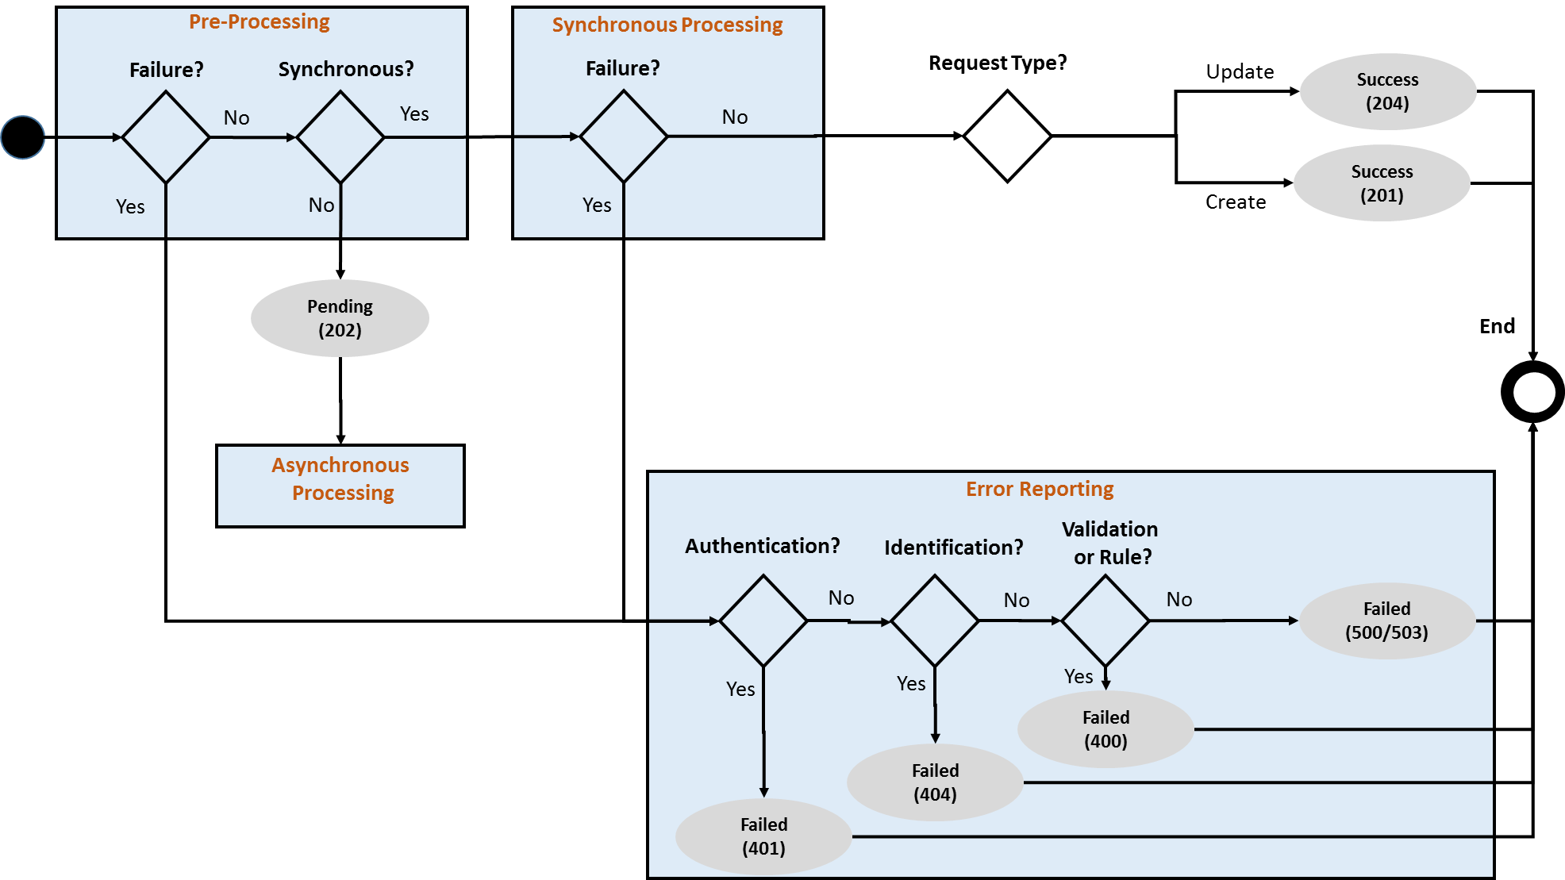

1. : Synchronous Request States

## API Behavioural Model

### Overview

API behaviour is governed by the following factors:

* The resource.
* The type of operation, i.e. create, update or read.
* Whether the provider will process the request synchronously.
* Whether the provider implements callback or polling methods for asynchronous processing.

When combined, these factors drive API behaviour from the simplest request (e.g. view an account balance) to a more complex request (e.g. update a debit mandate asynchronously).

### Request State Object

Asynchronous flows involve either a callback or a polling mechanism to enable to client to determine the final state of the request. Both mechanisms involve the use of the RequestState object as per below:

* **Callback**. A request is initiated via a HTTP POST or PATCH request with an intermediate response represented by a RequestState object. One the request has been completed, the provider will initiate a PATCH request to provide the client with the final RequestState.
* **Polling**. Is initiated by a HTTP POST or PATCH request with an intermediate response provided in the form of the RequestState object. A HTTP GET is then issued on the RequestState by the client at regular defined intervals until the final resource state is returned.

The object definition for RequestState is described below.

|  |  |  |  |  |  |
| --- | --- | --- | --- | --- | --- |
| RequestState Object Properties | | | | | |
| Name | **Type** | **Description** |  | **Reference** | **Validation** |
| serverCorrelationId | String | A unique identifier issued by the provider to enable the client to identify the RequestState resource on subsequent polling requests. | →NA  ←M |  | GUID |
| status | String | Indicates the status of the request. | →NA  ←M |  | Enumeration = pending, completed, failed |
| pendingReason | String | A textual description that can be provided to describe the reason for a pending status. | →NA  ←O |  |  |
| notificationMethod | DateTime | Indicates whether a callback will be issued or whether the client will need to poll. | →NA  ←M |  | Enumeration = callback, polling |
| objectReference | Reference | Provides a reference to the subject resource, e.g. transaction reference. | →NA  ←O |  |  |
| expiryTime | DateTime | Indicate the time by which the provider will fail the request if completion criteria have not been met. For an example, a debit party failing to authorise within the allowed time period. | →NA  ←O |  |  |
| pollLimit | Integer | Indicates the number of poll attempts for the given requeststate resource that will be allowed by the provider. | →NA  ←O |  |  |
| errorReference | Reference | If the asynchronous processing failed, details of the error will be returned here | →NA  ←O | Errors Object |  |

### Sequence Flows

There are seven sequence flows that can be implemented over the mobile money API. These are reflected in the attached sheet below. The sheet indicates the necessary HTTP operations, request object, response object and expected success and failure response codes for each API service.



### API Flow Patterns

Sequence diagrams 8.2 through 8.8 illustrate the standard flow patterns for the mobile money API. Note that Green flows represent a success path and red flows represent a failure path. A solid line indicates a HTTP request and a dotted line indicates a HTTP response.

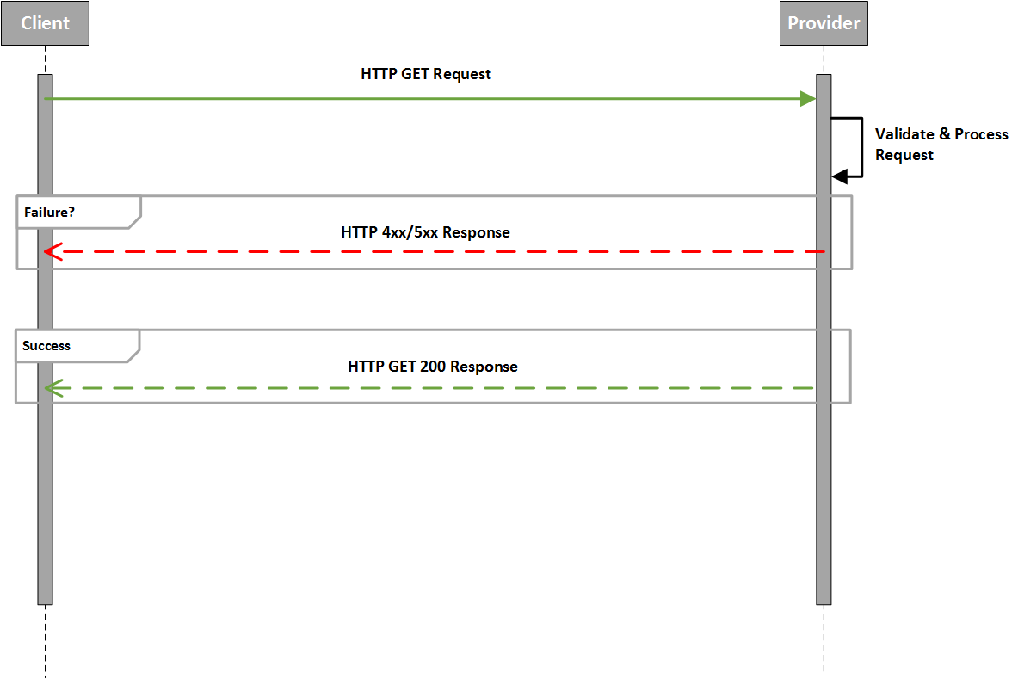

1. : Read (GET) Flow Pattern

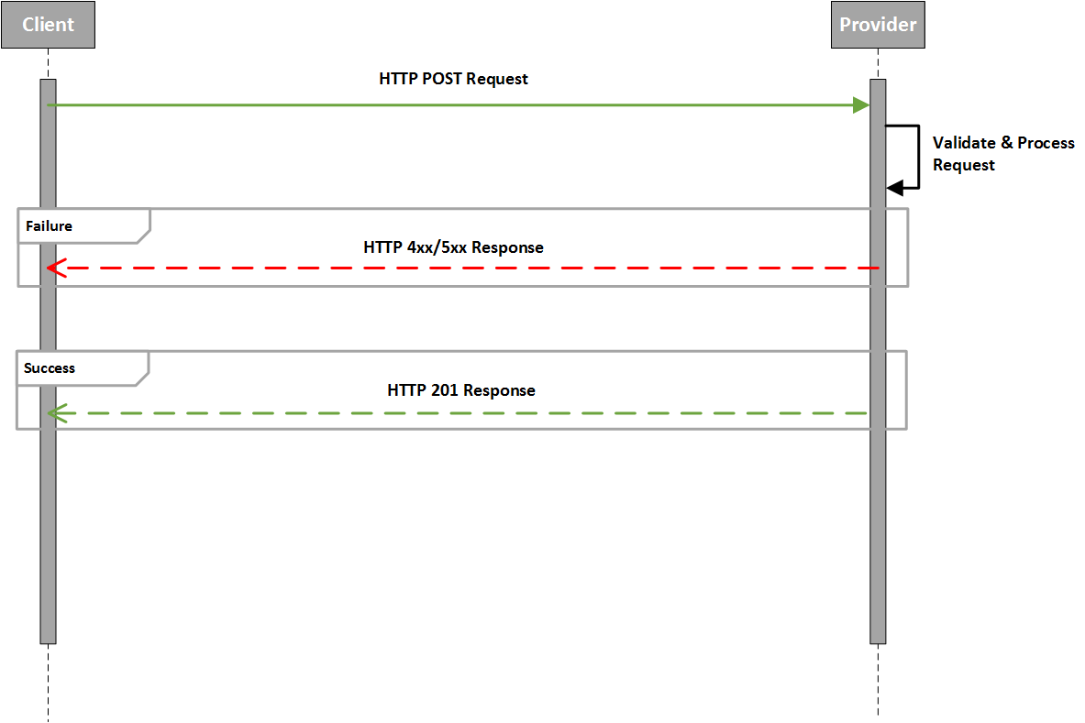

1. : Create (POST) Synchronous Flow Pattern

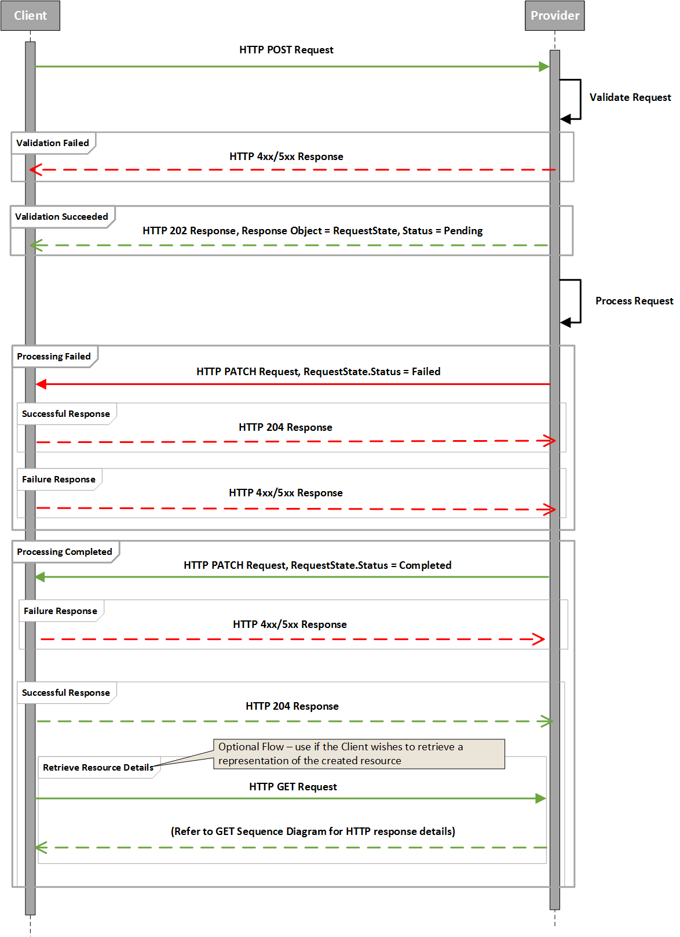

1. : Create (POST) Callback Asynchronous Flow Pattern

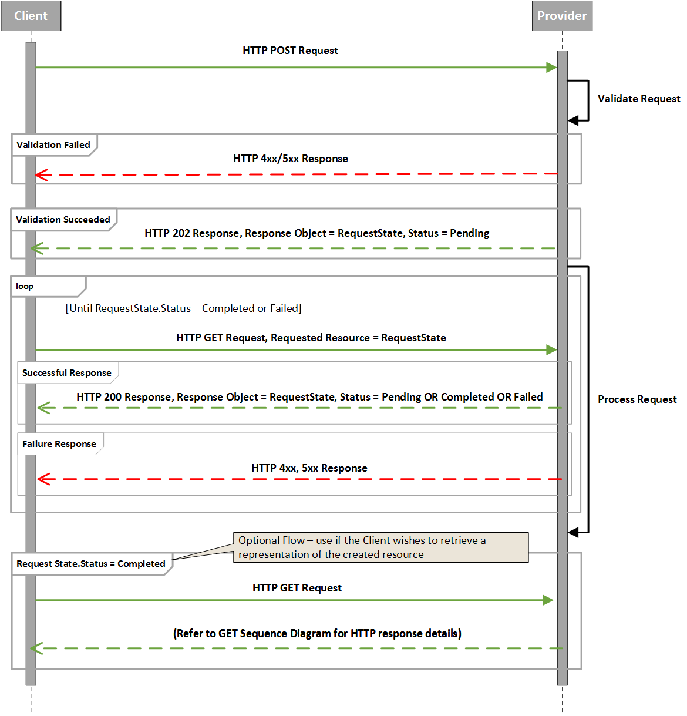

1. : Create (POST) Polling Asynchronous Flow Pattern

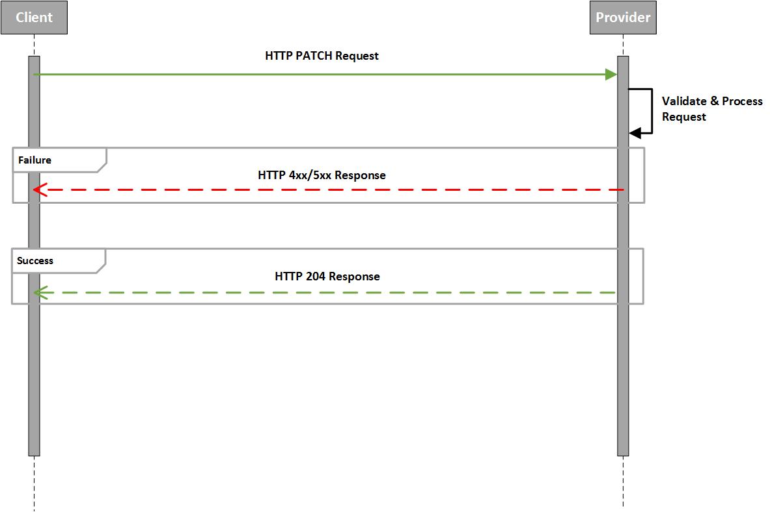

1. : Update (PATCH) Synchronous Flow Pattern

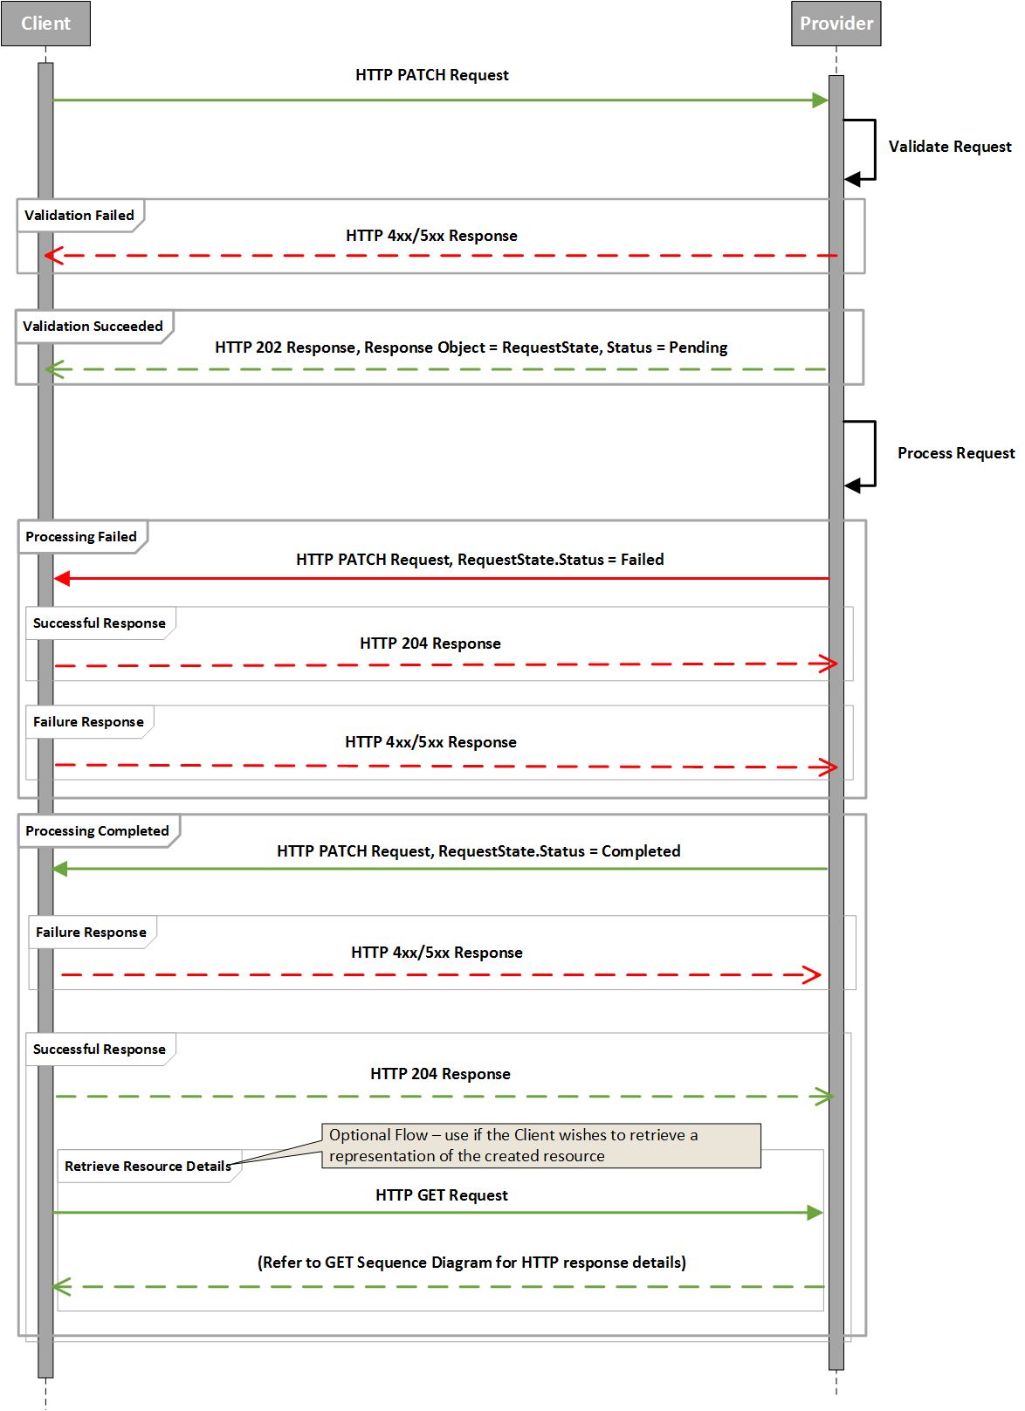

1. : Update (PATCH) Callback Asynchronous Flow Pattern

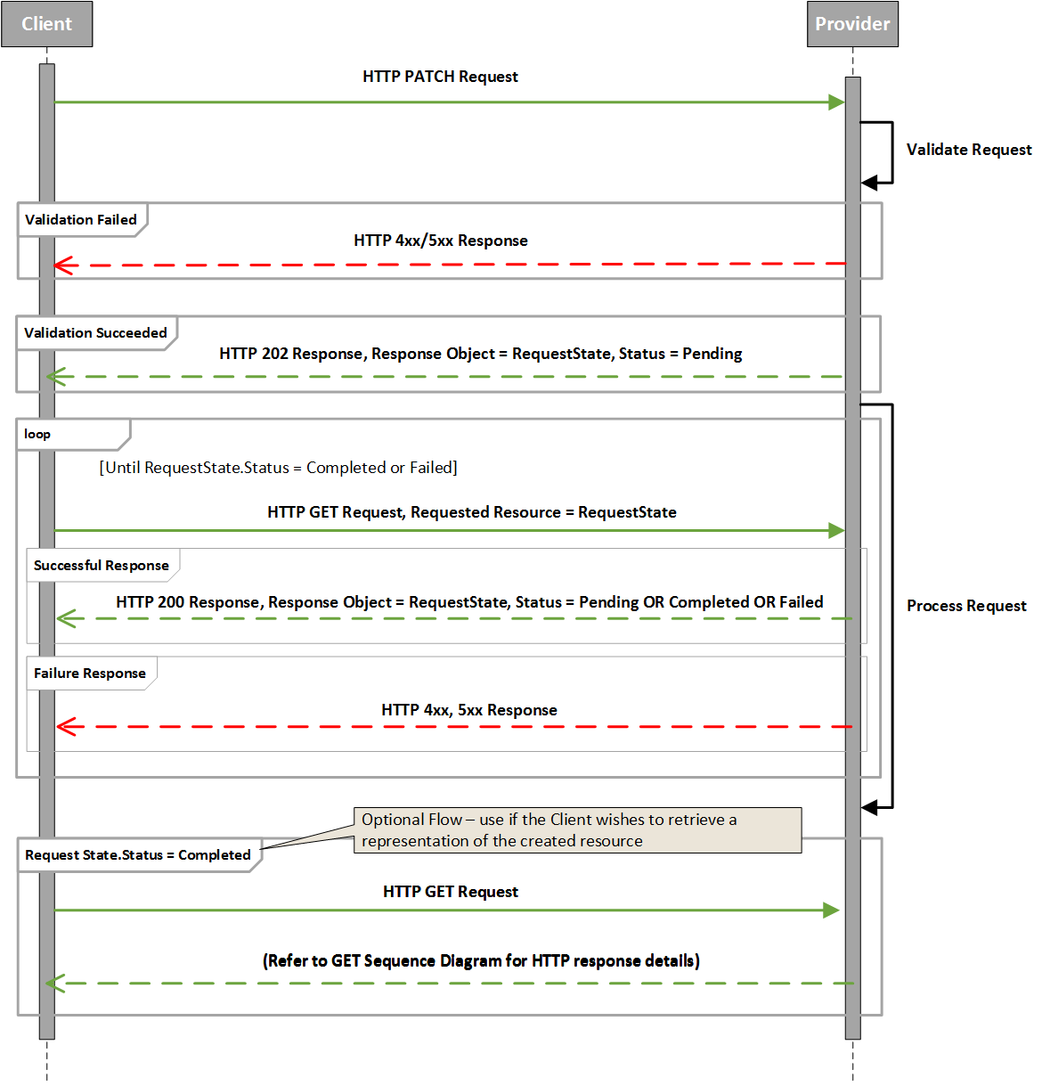

1. : Update (PATCH) Polling Asynchronous Flow Pattern

## HTTP Status Responses and Error Categories

At a high-level, the following HTTP status codes are returned for operations:

|  |  |  |  |  |
| --- | --- | --- | --- | --- |
| **Operation** | **Success** | **Intermediate\*** | **Client Error** | **Server Error** |
| GET | 200 | N/A | 400, 401, 404 | 500, 503 |
| PATCH | 204 | 202 | 400, 401, 404 | 500, 503 |
| POST | 201 | 202 | 400, 401, 404 | 500, 503 |

*Note that ‘intermediate’ in the table above relates to the HTTP response for the first leg of an asynchronous request.

### Client Error Categories

Client errors fall into one of four categories as shown below:

|  |  |  |
| --- | --- | --- |
| **Error Category** | **Description** | **HTTP Response Code** |
| BusinessRule | The resource could not be successfully completed due a violation of a business rule. Business rules include financial limit violations, duplicate requests and invalid states. | 400 |
| Validation | Violation of a constraint that will prevent the resource from being processed. Examples include:   * Invalid property length * Failure to resolve regular expression | 400 |
| Authorisation | It was not possible to authenticate or authorise the client or other party to perform the service | 401 |
| Identification | The requested resource could not be matched on the system with the supplied identifier(s). | 404 |

Additional non-harmonised 4xx HTTP response codes may be returned to the client by web or proxy servers.

Where the need for prevention of information leakage is paramount and this outweighs the benefits of error granularity, the provider may wish to use a 400 response code with no error body.

### Server Error Categories

Server Errors are captured in two simple categories as per the following table:

|  |  |  |
| --- | --- | --- |
| **Error Category** | **Description** | **HTTP Response Code** |
| Internal | The request could not be completed due to a non-client related issues that do not constitute complete system unavailability. Examples include software licence issues, unavailability of system configuration information. | 500 |
| Service Unavailable | The service is not currently available. This could be due to network issues, issues with individual components or complete systems outages. Regardless of the cause, the result means that the request cannot be performed. | 503 |

Additional non-harmonised 5xx HTTP response codes may be returned to the client by web or proxy servers.

## Error Codes Definition

The mobile money API uses harmonised error codes in order to provide consistent error reporting back to API clients. Error codes are structured as per follows

* Error Category. All error codes must be associated with a client or server error category. This provides context and uniqueness to the error code.
* Error Code. Provides the reason for the request failure. A human-readable description of the error is also available. Error codes are generally granular, i.e. they provide a specific reason for failure. In some cases, granularity is neither possible or desirable. Where this is the case, a ‘Generic’ code has been defined. Cases include:
  + - * The API Provider has generated an error that does not map to existing Rule error codes.
      * The API Provider wishes to avoid disclosure of confidential information regarding the resource or parties to the resource. For example, the fact that a customer has breached their monthly transaction limit may not be disclosed to specific clients.
* Error Parameters. Provides a construct to communicate supplementary information regarding the error in key/value pairs. The supplementary information is currently non-harmonised and can include:
  + - * The API provider-specific Error Code and Description.
      * Additional identification of the error subject, e.g. account identifiers, invalid properties etc…
      * Diagnostic information, e.g. affected subsystem, licence failure type etc…

Note that although error parameter contents are non-harmonised, care should be taken regarding confidentially of disclosed information. Confidential parameter information should only be disclosed to trusted clients.

A full list of harmonised Error Codes is provided in Appendix A.

## Errors Object Definition

All errors generated by the API provider will contain an Errors object in the response body. At a minimum, the Errors object must contain the Error Reason and Error Code.

|  |  |  |  |  |  |
| --- | --- | --- | --- | --- | --- |
| Errors Object Properties | | | | | |
| Name | **Type** | **Description** |  | **Reference** | **Validation** |
| errorCategory | String | The category grouping for the error. | →M  ←M |  | Enumeration = Error Categories |
| errorCode | String | The harmonised error code identifying the reason for error. | →M  ←M |  | Enumeration = Error Reasons |
| errorDescription | String | A textual Description of the error. | →O  ←O |  |  |
| errorDateTime | DateTime | The timestamp indicating when the error occurred. | →O  ←O |  |  |
| errorParameters | Reference | Diagnostic information in the form of key/value pairs relating to the error. | →O  ←O | Metadata |  |

## API Heartbeat

The Heartbeat API is used for monitoring purposes and establishes whether an API provider’s system is in a state that enables a client to submit a request for processing within established SLAs. There are three states that can be returned by the API provider in response to a heartbeat request:

* Available. The system is available and can receive and complete requests within SLAs.
* Degraded. The system can receive and complete requests but not within SLAs, i.e. delay in transaction processing is anticipated. When known, the expected processing delay time can be returned by the provider.
* Unavailable. The system cannot receive and process requests. Any submitted requests will fail whilst the system is in this state.

The Heartbeat can be requested using the following format:

* ***/heartbeat***. Issues heartbeat to determine availability of the transactions service, for example International Transfers.

Only synchronous API Heartbeat requests are supported. Note that the HTTP Request does not contain a request body. The HTTP response contains the following properties.

|  |  |  |  |  |  |
| --- | --- | --- | --- | --- | --- |
| Heartbeat Response Properties | | | | | |
| Name | **Type** | **Description** |  | **Reference** | **Validation** |
| serviceStatus | String | Provides the status of the requested service. | →NA  ←M |  | Enumeration = available, unavailable, degraded |
| delay | Number | The anticipated processing delay in milliseconds | →NA  ←O |  | Service Status must be set to degraded. |
| plannedRestorationTime | Datetime | Where the planned restoration time is known (e.g. scheduled maintenance), it can be provided in this property | →NA  ←O |  |  |

## Missing Response Retrieval

In some circumstances, the client may not have received the final representation of the resource for which it attempted to create. For example, a proxy server issue may have resulted in a HTTP 5xx response but the provider may have actually successfully completed the request. The /Responses API allows a client to identify and retrieve the final representation of the resource assuming that the resource was created. In order to get a representation, the client issues a GET /Responses/{Client Correlation ID}. The provider will then match the client correlation ID to the appropriate resource and return a link to that resource. If the resource is not found for the given correlation ID then a HTTP 404 will be returned.

The response object for ***/responses*** is detailed below.

|  |  |  |  |  |  |
| --- | --- | --- | --- | --- | --- |
| Responses Properties | | | | | |
| Name | **Type** | **Description** |  | **Reference** | **Validation** |
| link | String | Provides a URL to the resource associated with the given correlation ID | →NA  ←M |  |  |

## Harmonised Error Codes

The error codes defined in this section are considered a basic initial set and will be expanded over time.

|  |  |  |
| --- | --- | --- |
| **Error Category** | **Error Code** | **Error Code Description** |
| BusinessRule | GenericError | A generic Error Code for the Rule Error Category. This is used in two scenarios: 1. The API Provider has generated an error that does not map to existing Rule error codes. 2. The API Provider wishes to avoid disclosure of confidential information regarding the resource or parties to the resource. |
| BusinessRule | DailyVolumeLimitExceeded | The party has exceeded their daily transacting volume limit - This can be a service limit or a limit that is specific to the party. |
| BusinessRule | DailyValueLimitExceeded | The party has exceeded their daily transacting value limit - This can be a service limit or a limit that is specific to the party. |
| BusinessRule | WeeklyVolumeLimitExceeded | The party has exceeded their weekly transacting volume limit - This can be a service limit or a limit that is specific to the party. |
| BusinessRule | WeeklyValueLimitExceeded | The party has exceeded their weekly transacting value limit - This can be a service limit or a limit that is specific to the party. |
| BusinessRule | MonthlyVolumeLimitExceeded | The party has exceeded their monthly transacting volume limit - This can be a service limit or a limit that is specific to the party. |
| BusinessRule | MonthlyValueLimitExceeded | The party has exceeded their monthly transacting value limit - This can be a service limit or a limit that is specific to the party. |
| BusinessRule | AccountMaxTotalValueExceeded | The party has exceeded their cumulative transacting value limit defined for the account. |
| BusinessRule | AccountMaxTotalVolumeExceeded | The party has exceeded their cumulative transacting volume limit defined for the account. |
| BusinessRule | LessThanTransactionMinValue | The amount specified for the transaction is less than the defined minimum for the service. |
| BusinessRule | GreaterThanTransactionMaxValue | The amount specified for the transaction is greater than the defined maximum for the service. |
| BusinessRule | MaxBalanceExceed | The amount specified will cause the balance of the credit parties account to exceed the rule limit. |
| BusinessRule | SamePartiesError | The debit and credit parties are the same. |
| BusinessRule | DuplicateRequest | The request has previously been processed, i.e. this request is a duplicate and hence has been rejected. |
| BusinessRule | InsufficientFunds | Available funds are not sufficient to enable the party to be debited for the requested transaction. |
| BusinessRule | IncorrectState | The account is in a state that does not permit the requested service. |
| BusinessRule | UnderPaymentNotAllowed | The requested amount is less than the amount that needs to be supplied for this transaction |
| BusinessRule | OverPaymentNotAllowed | The requested amount is greater than the amount that needs to be supplied for this transaction |
| BusinessRule | RateLimitError | The client has submitted too many requests within a period of time. |
| BusinessRule | TransactionTypeError | The harmonised transaction type is not supported by the API Provider for the given request. |
| BusinessRule | NoMandateAuthority | The transaction request is not supported by the debit mandate. |
| BusinessRule | LinkViolation | The request has violated an account to account link for one of the following reasons:   * Pull request not supported by the Link Mode. * Push request not supported by the Link Mode. |
| BusinessRule | CountryofOriginNotPermitted | The API Provider does not allow transactions to be accepted from the specified country of origin. |
| BusinessRule | NationalityNotPermitted | The API Provider does not allow transactions to be accepted from individuals with the specified nationality. |
| BusinessRule | IdDocumentNotSupported | The API Provider does not allow the specified ID Document. |
| BusinessRule | IssuingCountryNotSupported | The API Provider does not allow the issuing country of the specified ID document. |
| QuoteExpiry | QuoteHasExpired | A transaction with a quote reference cannot be processed at the quote has expired. |
| Identification | IdentifierError | The requested resource could not be matched on the system with the supplied identifier(s). |
| Validation | GenericError | A generic Error Code for the Validation Error Category. This is used in where the API Provider has generated an error that does not map to existing Validation error codes. |
| Validation | LengthError | The specified property contents are greater than the maximum allowed length or less than the minimum allowed length. |
| Validation | FormatError | The specified property contents do not conform to the format required for this Property. |
| Validation | NegativeValue | The amount supplied is negative and this is not allowed for the given service. |
| Validation | CurrencyNotSupported | The currency supplied is not supported by the API Provider. |
| Validation | MandatoryValueNotSupplied | A mandatory value has not been provided in the header and/or JSON body. |
| Validation | InvalidOffset | The pagination offset provided is not valid. This is typically because the offset is greater than the maximum number of records. |
| Authorisation | ClientAuthorisationError | General Client Authentication failure. No further details provided to prevent leakage of security information. |
| Authorisation | RequestDeclined | The debit party did not approve the request. |
| Authorisation | ServicingPartyAuthorisationError | The servicing party (e.g. agent) credentials or permissions are not valid. |
| Authorisation | RequestingPartyAuthorisationError | The party requesting the service has not provided the right credentials and/or does not have permission to perform this service. |
| Internal | GenericError | The request could not be completed due to a non-client related issues that do not constitute complete system unavailability. Examples include software licence issues, unavailability of system configuration information. |
| Service Unavailable | GenericError | The service is not currently available. This could be due to network issues, issues with individual components or complete systems outages. Regardless of the cause, the result means that the request cannot be performed. |